BIOLOGY 2022-23 November 15, 2022

Today’s Agenda (Day 54)

- HOUSEKEEPING ITEMS

- Homework Check:

- Class Activity:
CAREER FAIR
QUIZ: Chapter 8 Vocabulary – as time permits, otherwise on Wednesday!

WEDNESDAY: DAY 2: Chapter 8 PPT Review
- Section 8.2 – Photosynthesis
- Section 8.3 – Cellular Respiration

HOMEWORK:
- READ: Chapter 8 – Cellular Energy
- COMPLETE:
- STUDY: Chapter 8 Vocabulary Quiz & Test

CHAPTER 8 VOCABULARY
Adenosine triphosphate | Aerobic process | Aerobic respiration | Anaerobic process | Calvin cycle
Cellular respiration | Energy | Fermentation | Glycolysis | Granum
Krebs cycle | Metabolism | NADP+ | Photosynthesis | Pigment
Rubisco | Stroma | Thermodynamics | thylakoid

REMINDERS:

- Mini-Lab 7.2 – Investigate Osmosis – Nov. 16
- QUIZ: Chapter 8 Vocabulary – Nov. 16 NOTE CHANGE OF DATE! [If not on TUESDAY]
- TEST: Ch 8 Nov. 17

BIOLOGY 2022-23 READING GUIDE

Chapter 8 Cellular Energy
Review pages 218 - 233 in the Glencoe Science Biology Textbook and answer the following questions.
- What is energy? Describe three activities in a cell that require energy.
- State the law of conservation of energy. Give an example.
- State the 2nd law of thermodynamics. Give an example.
- Compare and contrast autotrophs and heterotrophs.
- Compare and contrast anabolic pathways and catabolic pathways.
- Give an example of an anabolic pathway. Give an example of a catabolic pathway.
- Why is photosynthesis and cellular respiration considered cyclical processes?
- Describe the structure of an ATP molecule.
- Explain how your body uses ATP.
- Look at Figure 4 and explain what is being illustrated.
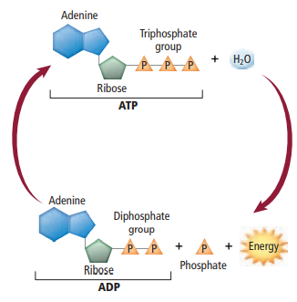
- What is photosynthesis? What molecules are needed in order for a plant to be able to undergo photosynthesis? What are the products of photosynthesis?
- Summarize the two phases of photosynthesis.
- Describe the structure of a chloroplast.
- Describe what is shown on the graph below.
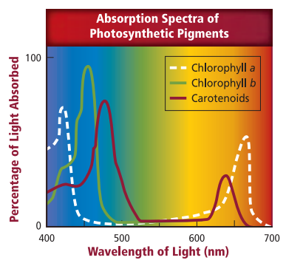
- What role do accessory pigments play in plants?
- Describe what happens during photosystem II.
- Describe what happens during photosystem I.
- Describe how ATP is made as a result of chemiosmosis.
- What is the end result of the Calvin cycle?
- Describe two alternative photosynthetic pathways for hot and dry environments.
- Compare and contrast aerobic and anaerobic respiration.
- What happens during glycolysis?
- What happens during the Kreb’s cycle? Is the Kreb’s cycle aerobic or anaerobic?
- How many ATP are made in the electron transport chain?
- Describe what happens after glycolysis if no oxygen is present within a cell.
- Compare and contrast lactic acid fermentation and alcoholic fermentation.
- How are the processes of cellular respiration and photosynthesis related?

BIOLOGY 2022-23 MINI LAB

CHAPTER 7.2 MINI LAB – Investigate Osmosis
What will happen to cells placed in a strong salt solution? Regulating flow and amount of water into and out of the cell is critical to the survival of that cell. Osmosis is one method used to regulate a cell’s water content.
Procedure
1. Read and complete the lab safety form.
2. Prepare a control slide using onion epidermis, water, and iodine stain as directed by your teacher.
3. Prepare a test slide using onion epidermis, salt water, and iodine stain as directed by your teacher.
4. Predict the effect, if any, that the salt solution will have on the onion cells in the test slide.
5. View the control slide using a compound microscope under low power and sketch several onion cells.
6. View the test slide under the same magnification and sketch your observations.
Analysis
1. Analyze and Conclude Was your prediction correct or incorrect? Explain.
2. Explain Use the process of osmosis to explain what you observe.

