BIOLOGY 2022-23 November 2, 2022

Today’s Agenda (Day 4)

- HOUSEKEEPING ITEMS

- Homework Check:
Mini-lab: Enzymatic Browning
- Class Activity:
WEDNESDAY: DAY 2: Chapter 7 PPT Review
- Section 7.3 – Structures and Organelles
- Section 7.4 – Cellular Transport

THURSDAY: QUIZ: Ch 7 Vocabulary
*Go to www.socrative.com enter room “MSBBIOLOGY” enter ID #
FRIDAY: Mini-Lab 7.1 – Discover Cells
MONDAY: Mini-Lab 7.2 – Investigate Osmosis
HOMEWORK:
- READ: Chapter 7 – Cell Structure and Function
- COMPLETE: Chapter 7 Reading Guide Questions
- STUDY: Chapter 6 Test, Chapter 7 Vocabulary and Test

CHAPTER 7 VOCABULARY
Active transport | Cell | Cell theory | Cell wall | Centriole | Chloroplast
Cilium | Cytoplasm | Cytoskeleton | Diffusion | Dynamic equilibrium | Endocytosis
Endoplasmic reticulum | Eukaryotic cell | Exocytosis | Facilitated diffusion | Flagellum | Fluid mosaic model
Golgi apparatus | Hypertonic solution | Hypotonic solution | Isotonic solution | Lysosome | Mitochondrion
Nucleolus | Nucleus | Organelle | Osmosis | Phospholipid bilayer | Plasma membrane
Prokaryotic cell | Ribosome | Selective permeability | Transport protein | vacuole

REMINDERS:

- QUIZ: Ch 7 Vocabulary Nov. 3
- Chapter 7 Reading Guide – Nov. 3
- TEST: Ch 7 Nov. 8

BIOLOGY 2022-23 READING GUIDE

Chapter 7 Cellular Structure & Function
Review pages 182 – 207 in the Glencoe Science Biology Textbook and answer the following questions.
- List the three principles of the Cell Theory.
- Describe one strength and one weakness of both a compound light microscope and an electron microscope.
- What is the essential function of the plasma membrane?
- Compare and contrast eukaryotic cells and prokaryotic cells.
- Describe the endosymbiont theory.
- When describing the plasma membrane, selectively permeable and phospholipid bilayer are almost always mentioned. What do these terms mean?
- What are transport proteins used for in the plasma membrane?
- Some scientists consider the role of cytoplasm more vital (important) in prokaryotes rather than eukaryotes. Explain why.
- Draw the eukaryotic cell below and label and define all organelles listed on Table (p199).
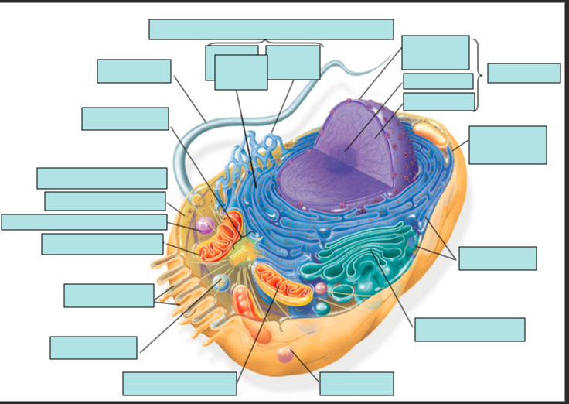
- Would you expect to find more mitochondria in a muscle cell or a skin cell? Explain your answer.
- Plant cells have a cell wall (animal cells don’t), what is its function?
- Describe the process of protein synthesis mentioning all the organelles involved in the process.
- Define diffusion. Give an example.
- What is meant by the term dynamic equilibrium?
- How is facilitated diffusion different from simple diffusion?
- How does osmosis work?
- Define isotonic solution, hypotonic solution, and hypertonic solution.
- Describe how a cell behaves in each of the following: isotonic solution, hypotonic solution, and hypertonic solution.
- Determine which type of solution each red blood cell is in from each of the diagrams below:
A.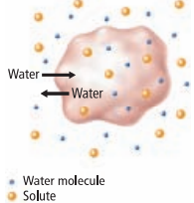 B. 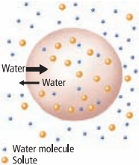 C.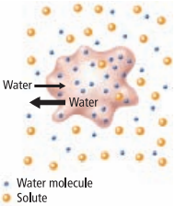

- What is the main difference between active transport and diffusion?
- Compare and contrast exocytosis and endocytosis.

BIOLOGY 2022-23 MINI LAB

CHAPTER 7.1 MINI LAB – Discover Cells
How can you describe a new discovery? Imagine you are a scientist looking through the eyepiece of some new-fangled instrument called a microscope and you see a field of similarly shaped objects. You might recognize that the shapes you see are not merely coincidence and random objects. Your whole idea of the nature of matter is changing as you view these objects.
Procedure
1. Read and complete the lab safety form.
2. Prepare a data table in which you will record observations and drawings for three slides.
3. View the slide images your teacher projects for the class.
4. Describe and draw what you see. Be sure to include enough detail in your drawings to convey the information to other scientists who have not observed cells.

Analysis
1. Describe What analogies or terms could explain the images in your drawings?
2. Explain How could you show Hooke, with twenty-first-century technology, that his findings were valid?

BIOLOGY 2022-23 MINI LAB

CHAPTER 7.2 MINI LAB – Investigate Osmosis
What will happen to cells placed in a strong salt solution? Regulating flow and amount of water into and out of the cell is critical to the survival of that cell. Osmosis is one method used to regulate a cell’s water content.
Procedure
1. Read and complete the lab safety form.
2. Prepare a control slide using onion epidermis, water, and iodine stain as directed by your teacher.
3. Prepare a test slide using onion epidermis, salt water, and iodine stain as directed by your teacher.
4. Predict the effect, if any, that the salt solution will have on the onion cells in the test slide.
5. View the control slide using a compound microscope under low power and sketch several onion cells.
6. View the test slide under the same magnification and sketch your observations.
Analysis
1. Analyze and Conclude Was your prediction correct or incorrect? Explain.
2. Explain Use the process of osmosis to explain what you observe.

