BIOLOGY 2022-23 September 30, 2022

Today’s Agenda (Day 32)

- HOUSEKEEPING ITEMS

- Homework Check:
LAB: Design your own Biome [final]
Chapter 5 Vocabulary
LAB: Population Ecology
Chemistry Table
- Class Activity:
DAY 3: Chapter 5 PPT Review
- Section 5.2 – Threats to Biodiversity
- Section 5.3 – Conserving Biodiversity

HOMEWORK:
- READ: Chapter 5 – Biodiversity and Conservation
- COMPLETE: Ch 5 Reading Guide
- STUDY: Chapter 5 Test, Ch 5 & 6 Vocabulary Quiz

CHAPTER 5 – Biodiversity and Conservation
Background extinction | Biological augmentation | Biological magnification | Bioremediation | Ecosystem diversity | Edge effect
Endemic | Eutrophication | Extinction biodiversity | Genetic diversity | Habitat fragmentation | Introduced species
Mass extinction | Natural resource | Overexploitation | Renewable resource | Species diversity | Sustainable use
CHAPTER 6 – Chemistry in Biology
Acid | Activation energy | Active site | Amino acid | Atoms | Base
Buffer | Carbohydrate | Catalyst | Chemical reaction | Compound | Covalent bond
Electron | Element | Enzyme | Hydrogen bond | Ion | Ionic bond
Isotope | Lipid | Macromolecule | Mixture | Molecule | Neutron
Nucleic acid | Nucleotide | Nucleus | pH | Polymer | Polar molecule
Product | Protein | Proton | Reactant | Solute | Solution
Solvent | Substrate | Van der Waals force

ELEMENTS AND SYMBOLS
Hydrogen - | Helium - | Lithium - | Beryllium - | Boron - | Carbon - | Nitrogen - | Oxygen - | Fluorine -
Neon - | Sodium - | Magnesium - | Aluminum - | Silicon - | Phosphorus- | Sulfur - | Chlorine - | Argon -
Potassium- | Calcium - | Chromium - | Manganese - | Iron - | Cobalt - | Nickel - | Copper - | Zinc -
Arsenic - | Selenium - | Bromine - | Krypton - | Palladium - | Silver - | Cadmium - | Tin - | Iodine -
Xenon - | Cesium - | Barium - | Platinum - | Gold - | Mercury - | Lead - | Radon - | Radium -
POLYATOMIC IONS & COMMON ACIDS
Acetate | Acetate | Ammonium | Bromate | Carbonate | Chlorate | Chlorite | Chromate | Cyanate
Cyanide | Dichromate | dihydrogen phosphate | hydrogen carbonate / bicarbonate | hydrogen phosphate | hydrogen sulfate / bisulfate | Hydroxide | Hypochlorite | Iodate
Nitrate | Nitrite | Oxalate | Perchlorate | Permanganate | Peroxide | Phosphate | Phosphite | Sulfate
Sulfite | Thiocyanate | Thiosulfate
Acetic | Bromic | Chloric | Chlorous | Hydrobromic | Hydrochloric | Nitric | Phosphoric | Sulfuric

REMINDERS:
- CHEMISTRY TABLE – Polyatomic Ions & Acids – Sept. 30
- QUIZ: Chemicals and Symbols [elements, polyatomic ions, acids] Oct. 11
- Chapter 5 Reading Guide – Oct. 11
- TEST: Ch 5 Oct. 13
- QUIZ: Ch 5 & 6 Vocabulary – Oct. 18
- TEST: Ch 6 Oct. 20

BIOLOGY 2022-23 CHEMISTRY REINFORCEMENT

Chemicals and Symbols

INSTRUCTIONS: Please complete the table below with the appropriate chemical symbols (and ionic charge)for each common polyatomic ions and acids listed.

POLYATOMIC IONS & COMMON ACIDS
Acetate | Acetate | Ammonium | Bromate | Carbonate | Chlorate | Chlorite | Chromate | Cyanate
Cyanide | Dichromate | dihydrogen phosphate | hydrogen carbonate / bicarbonate | hydrogen phosphate | hydrogen sulfate / bisulfate | Hydroxide | Hypochlorite | Iodate
Nitrate | Nitrite | Oxalate | Perchlorate | Permanganate | Peroxide | Phosphate | Phosphite | Sulfate
Sulfite | Thiocyanate | Thiosulfate
Acetic | Bromic | Chloric | Chlorous | Hydrobromic | Hydrochloric | Nitric | Phosphoric | Sulfuric

BIOLOGY 2022-23 READING GUIDE

Chapter 5 Biodiversity & Conservation
Review pages 116 – 135 in the Glencoe Science Biology Textbook and answer the following questions.
- How do extinctions affect biodiversity?
- List and describe three types of biodiversity.
- Give an example of the three types of biodiversity you listed in number 2.
- Why does maintaining biodiversity have a direct economic value to humans?
- Differentiate between the direct and indirect economic value of biodiversity.
- What types of events can lead to extinction?
- According to the table, which of these groups has suffered the largest percentage loss due to extinction?
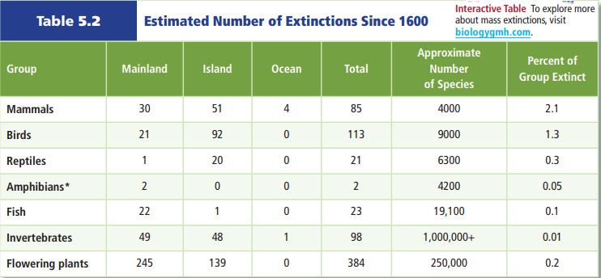
- According to the table above, which of these groups has suffered the smallest percentage loss due to extinction?
- Why are non-native species introductions potentially so dangerous to island organisms?
- How are today’s high rates of extinction different from past mass extinction events?
- What normally happens after a mass extinction? Why might this not happen after this mass extinction?
- What is overexploitation? How does it affect biodiversity?
- How can disruption of a habitat be as harmful as destruction of a habitat?

- Describe how habitat fragmentation can lead to edge effects (describe edge effects as part of your answer).
- What causes eutrophication? What are the problems associated with eutrophication?
- Why are introduced species a threat to biodiversity in their new habitat, but not their original habitat?
- What conclusion can be made based on this graph?
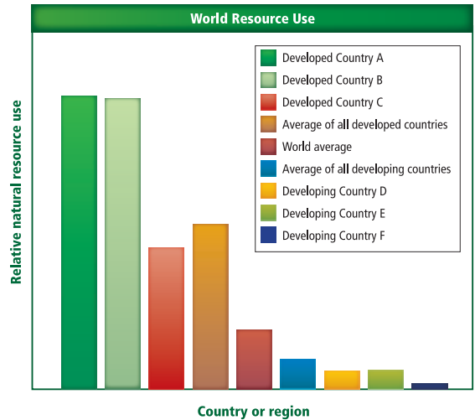
- What is the difference between renewable and nonrenewable resources? Give two examples of each.
- Based on the graph below, how long does it take an area to recover from a landslide?
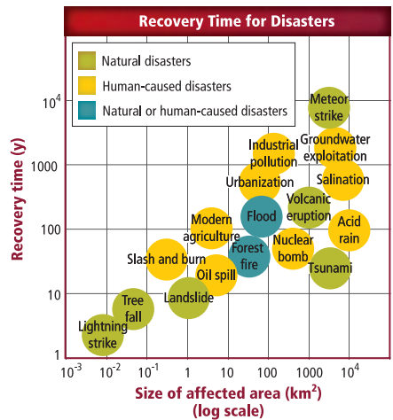
- Based on the graph above, what has the greatest influence on disaster recovery time?
- Choose a human-caused disaster from the graph above. Discuss the methods that could be used to restore biodiversity.
- Read the article on page 136 and what Wangari Maathai did in Kenya and how it has positively impacted her country.

