BIOLOGY 2022-23 September 28, 2022

Today’s Agenda (Day 30)

- HOUSEKEEPING ITEMS

- Homework Check:
LAB: Design your own Biome [final]

- Class Activity:
DAY 1: Chapter 5 PPT Review
- Section 5.1 – Biodiversity
- Section 5.2 – Threats to Biodiversity
- Section 5.3 – Conserving Biodiversity

HOMEWORK:
- READ: Chapter 4 – Population Ecology
- READ: Chapter 5 – Biodiversity and Conservation
- COMPLETE: Lab – Population Ecology AND Ch 5 Vocabulary [abridged template], Ch 5 Reading Guide
- STUDY: Chapter 5 Test, Ch 5 & 6 Vocabulary Quiz

CHAPTER 5 – Biodiversity and Conservation
Background extinction | Biological augmentation | Biological magnification | Bioremediation | Ecosystem diversity | Edge effect
Endemic | Eutrophication | Extinction biodiversity | Genetic diversity | Habitat fragmentation | Introduced species
Mass extinction | Natural resource | Overexploitation | Renewable resource | Species diversity | Sustainable use
CHAPTER 6 – Chemistry in Biology
Acid | Activation energy | Active site | Amino acid | Atoms | Base
Buffer | Carbohydrate | Catalyst | Chemical reaction | Compound | Covalent bond
Electron | Element | Enzyme | Hydrogen bond | Ion | Ionic bond
Isotope | Lipid | Macromolecule | Mixture | Molecule | Neutron
Nucleic acid | Nucleotide | Nucleus | pH | Polymer | Polar molecule
Product | Protein | Proton | Reactant | Solute | Solution
Solvent | Substrate | Van der Waals force

ELEMENTS AND SYMBOLS
Hydrogen - | Helium - | Lithium - | Beryllium - | Boron - | Carbon - | Nitrogen - | Oxygen - | Fluorine -
Neon - | Sodium - | Magnesium - | Aluminum - | Silicon - | Phosphorus- | Sulfur - | Chlorine - | Argon -
Potassium- | Calcium - | Chromium - | Manganese - | Iron - | Cobalt - | Nickel - | Copper - | Zinc -
Arsenic - | Selenium - | Bromine - | Krypton - | Palladium - | Silver - | Cadmium - | Tin - | Iodine -
Xenon - | Cesium - | Barium - | Platinum - | Gold - | Mercury - | Lead - | Radon - | Radium -
POLYATOMIC IONS & COMMON ACIDS
Acetate | Acetate | Ammonium | Bromate | Carbonate | Chlorate | Chlorite | Chromate | Cyanate
Cyanide | Dichromate | dihydrogen phosphate | hydrogen carbonate / bicarbonate | hydrogen phosphate | hydrogen sulfate / bisulfate | Hydroxide | Hypochlorite | Iodate
Nitrate | Nitrite | Oxalate | Perchlorate | Permanganate | Peroxide | Phosphate | Phosphite | Sulfate
Sulfite | Thiocyanate | Thiosulfate
Acetic | Bromic | Chloric | Chlorous | Hydrobromic | Hydrochloric | Nitric | Phosphoric | Sulfuric

REMINDERS:
- Chapter 5 Vocabulary – Sept. 28
- LAB: Population Ecology – Sept. 29
- CHEMISTRY TABLE – Polyatomic Ions & Acids
- QUIZ: Chemicals and Symbols [elements, polyatomic ions, acids] Oct. 11
- Chapter 5 Reading Guide – Oct. 11
- TEST: Ch 5 Oct. 13
- QUIZ: Ch 5 & 6 Vocabulary – Oct. 18
- TEST: Ch 6 Oct. 20

BIOLOGY 2022-23 CHEMISTRY REINFORCEMENT

Chemicals and Symbols

INSTRUCTIONS: Please complete the table below with the appropriate chemical symbols (and ionic charge)for each common polyatomic ions and acids listed.

POLYATOMIC IONS & COMMON ACIDS
Acetate | Acetate | Ammonium | Bromate | Carbonate | Chlorate | Chlorite | Chromate | Cyanate
Cyanide | Dichromate | dihydrogen phosphate | hydrogen carbonate / bicarbonate | hydrogen phosphate | hydrogen sulfate / bisulfate | Hydroxide | Hypochlorite | Iodate
Nitrate | Nitrite | Oxalate | Perchlorate | Permanganate | Peroxide | Phosphate | Phosphite | Sulfate
Sulfite | Thiocyanate | Thiosulfate
Acetic | Bromic | Chloric | Chlorous | Hydrobromic | Hydrochloric | Nitric | Phosphoric | Sulfuric

BIOLOGY 2022-23 LABPopulation Ecology Lab
Determining the Number of Goldfish in a Pond

Pre-Lab Discussion
Biologists often must determine the total number of organisms in a large area. If the organisms in the population being studied do not move around, the Random sampling technique can successfully provide an estimate of population size. Another technique must be used with populations such as the fish in a lake. This technique is called the “mark & recapture” method.

Purpose
Estimate population size using the mark & recapture technique

Hypothesis: How many fish do you estimate are in the pond (zip lock bag)? (You do not have to use the if…then…b/c… method)

Materials (per group)

Bag of Goldfish crackers
1 gallon zip lock bag
1 medicine measuring cup
marker pen (any color
Procedures
Obtain a population of goldfish in a pond (You may recognize that these are goldfish crackers in a gallon zip lock bag. A good model of an aquatic ecosystem.)
- Make sure your population of goldfish is well mixed.
- Notice that a 0 is present in Column A of Sample 1 to indicate that there are no marked goldfish present in the population before you start your study.
- Remove a sample of goldfish from your pond with a medicine measuring cup. Make sure the medicine cup is filled to the top with fish. Record the number of goldfish in your sample in column B.
- Use a marker pen to make a mark on the body of each of the goldfish in your sample. Now you have “marked” the first members of your population indicating that they have been captured!
- Record the number of goldfish you marked in Column D and return your marked goldfish to the population.
- In Column A (of sample 2) record the total number of marked goldfish that are now present in your population.
- Mix your population of goldfish and withdraw another medicine measuring cup full.
  - Record the total number of goldfish in this sample (both marked and unmarked) in Column B
  - Also record how many marked goldfish you have “recaptured” in Column C, and how many goldfish were captured for the first time in Column D.
- Mark each unmarked goldfish in this sample with the marker. Return all the marked fish to the population.
- In Column A record the total number of marked goldfish that are now present in your population (the sum of all the goldfish you have marked so far).
- Repeat this procedure. Fill in the data table.
- For the last 4 samples use the following equation to calculate the total population size.
# Marked goldfish in sample (C) = total # marked goldfish in population (A)
# Total goldfish in sample (B) total number of goldfish in population (E)

Remember that the total number of marked goldfish in the population will increase each time you take a sample and return more marked goldfish to the population.
Sample | Column A  # of marked goldfish in starting population | Column B  # of goldfish in sample | Column C  # marked goldfish in sample | Column D  # goldfish we mark and return to population | Column E  Population Estimate
1 | 0 |  | 0 |  | XXXX
2 |  |  |  |  | XXXX
3 |  |  |  |  | XXXX
4 |  |  |  |  | XXXX
5 |  |  |  |  | XXXX
6 |  |  |  |  | XXXX
7 |  |  |  |  | XXXX
8 |  |  |  |  | XXXX
9
10
11

Average the population estimates for the last 4 samples. This is the estimated population size. ___

Now count your population and see how closely the estimated number of goldfish agrees with the actual number of goldfish. Actual number _________

Calculate the percent error your estimates had. ESTIMATE population size minus ACTUAL population size. Divide that value by the ACTUAL population size. Multiply by 100: ______

Conclusion Questions

- Why do we use the “mark & recapture” method rather than just counting all the organisms in a population?

- Why would we use this technique instead of the random sampling method with fish in a pond?

- When else might scientists use this technique in nature?

- How did your hypothesis compare to your estimated population size? How did it compare to the actual population size?

- Why do scientists even need to estimate the size of a population?

- If a population decreases significantly in a given area, what could be some reasons for this drop in numbers?

- What happens if a population keeps getting exponentially higher? How does nature keep a balance on the population?
BIOLOGY 2022-23 READING GUIDE

Chapter 5 Biodiversity & Conservation
Review pages 116 – 135 in the Glencoe Science Biology Textbook and answer the following questions.
- How do extinctions affect biodiversity?
- List and describe three types of biodiversity.
- Give an example of the three types of biodiversity you listed in number 2.
- Why does maintaining biodiversity have a direct economic value to humans?
- Differentiate between the direct and indirect economic value of biodiversity.
- What types of events can lead to extinction?
- According to the table, which of these groups has suffered the largest percentage loss due to extinction?
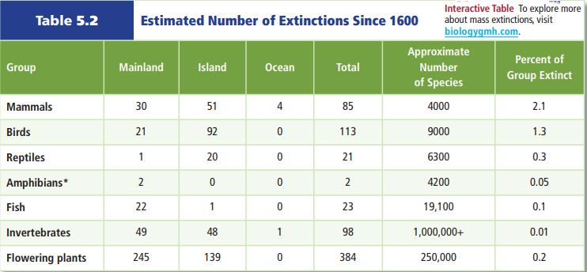
- According to the table above, which of these groups has suffered the smallest percentage loss due to extinction?
- Why are non-native species introductions potentially so dangerous to island organisms?
- How are today’s high rates of extinction different from past mass extinction events?
- What normally happens after a mass extinction? Why might this not happen after this mass extinction?
- What is overexploitation? How does it affect biodiversity?
- How can disruption of a habitat be as harmful as destruction of a habitat?

- Describe how habitat fragmentation can lead to edge effects (describe edge effects as part of your answer).
- What causes eutrophication? What are the problems associated with eutrophication?
- Why are introduced species a threat to biodiversity in their new habitat, but not their original habitat?
- What conclusion can be made based on this graph?
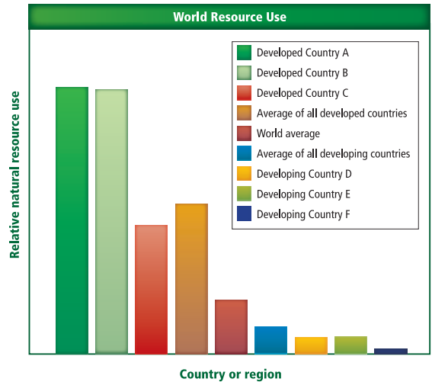
- What is the difference between renewable and nonrenewable resources? Give two examples of each.
- Based on the graph below, how long does it take an area to recover from a landslide?
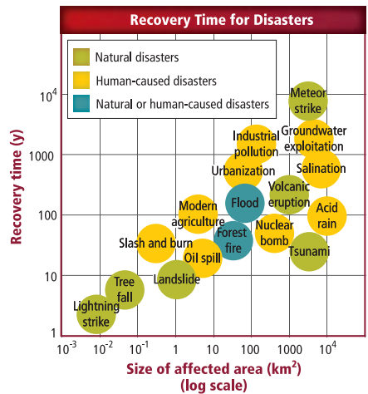
- Based on the graph above, what has the greatest influence on disaster recovery time?
- Choose a human-caused disaster from the graph above. Discuss the methods that could be used to restore biodiversity.
- Read the article on page 136 and what Wangari Maathai did in Kenya and how it has positively impacted her country.

