BIOLOGY 2022-23 September 23, 2022

Today’s Agenda (Day 27)

- HOUSEKEEPING ITEMS

- Homework Check:
Chapter 4 Vocabulary
Chapter 4 Reading Guide Questions
LAB: Design your own Biome [final]

- Class Activity:
LAB: Population Ecology – work in PAIRS or THREES see p. 2 of document

MONDAY: DAY 4: Chapter 4 PPT Review
- Section 4.2 – Human Population

HOMEWORK:
- READ: Chapter 4 – Population Ecology
- READ: Chapter 5 – Biodiversity and Conservation
- COMPLETE: Biome Lab Final Report AND Chapter 5 Vocabulary [abridged template]
- STUDY: Chapter 4 Test
CHAPTER 5 – Biodiversity and Conservation
Background extinction | Biological augmentation | Biological magnification | Bioremediation | Ecosystem diversity | Edge effect
Endemic | Eutrophication | Extinction biodiversity | Genetic diversity | Habitat fragmentation | Introduced species
Mass extinction | Natural resource | Overexploitation | Renewable resource | Species diversity | Sustainable use

REMINDERS:
- LAB: Design your own Biome [final] – Sept. 24, 1 PM
- TEST: Ch 4 Sept. 22 Sept. 27
- Chapter 5 Vocabulary – Sept. 28
- LAB: Population Ecology – Sept. 29
- Chapter 5 Reading Guide – Oct. 11
- TEST: Ch 5 Oct. 13
- QUIZ: Ch 5 & 6 Vocabulary – Oct. 18
- TEST: Ch 6 Oct. 20

BIOLOGY 2022-23 LABPopulation Ecology Lab
Determining the Number of Goldfish in a Pond

Pre-Lab Discussion
Biologists often must determine the total number of organisms in a large area. If the organisms in the population being studied do not move around, the Random sampling technique can successfully provide an estimate of population size. Another technique must be used with populations such as the fish in a lake. This technique is called the “mark & recapture” method.

Purpose
Estimate population size using the mark & recapture technique

Hypothesis: How many fish do you estimate are in the pond (zip lock bag)? (You do not have to use the if…then…b/c… method)

Materials (per group)

Bag of Goldfish crackers
1 gallon zip lock bag
1 medicine measuring cup
marker pen (any color)

Procedures
Obtain a population of goldfish in a pond (You may recognize that these are goldfish crackers in a gallon zip lock bag. A good model of an aquatic ecosystem.)
- Make sure your population of goldfish is well mixed.
- Notice that a 0 is present in Column A of Sample 1 to indicate that there are no marked goldfish present in the population before you start your study.
- Remove a sample of goldfish from your pond with a medicine measuring cup. Make sure the medicine cup is filled to the top with fish. Record the number of goldfish in your sample in column B.
- Use a marker pen to make a mark on the body of each of the goldfish in your sample. Now you have “marked” the first members of your population indicating that they have been captured!
- Record the number of goldfish you marked in Column D and return your marked goldfish to the population.
- In Column A (of sample 2) record the total number of marked goldfish that are now present in your population.
- Mix your population of goldfish and withdraw another medicine measuring cup full.
  - Record the total number of goldfish in this sample (both marked and unmarked) in Column B
  - Also record how many marked goldfish you have “recaptured” in Column C, and how many goldfish were captured for the first time in Column D.
- Mark each unmarked goldfish in this sample with the marker. Return all the marked fish to the population.
- In Column A record the total number of marked goldfish that are now present in your population (the sum of all the goldfish you have marked so far).
- Repeat this procedure. Fill in the data table.
- For the last 4 samples use the following equation to calculate the total population size.
# Marked goldfish in sample (C) = total # marked goldfish in population (A)
# Total goldfish in sample (B) total number of goldfish in population (E)

Remember that the total number of marked goldfish in the population will increase each time you take a sample and return more marked goldfish to the population.
Sample | Column A  # of marked goldfish in starting population | Column B  # of goldfish in sample | Column C  # marked goldfish in sample | Column D  # goldfish we mark and return to population | Column E  Population Estimate
1 | 0 |  | 0 |  | XXXX
2 |  |  |  |  | XXXX
3 |  |  |  |  | XXXX
4 |  |  |  |  | XXXX
5 |  |  |  |  | XXXX
6 |  |  |  |  | XXXX
7 |  |  |  |  | XXXX
8 |  |  |  |  | XXXX
9
10
11

Average the population estimates for the last 4 samples. This is the estimated population size. ___

Now count your population and see how closely the estimated number of goldfish agrees with the actual number of goldfish. Actual number _________

Calculate the percent error your estimates had. ESTIMATE population size minus ACTUAL population size. Divide that value by the ACTUAL population size. Multiply by 100: ______

Conclusion Questions

- Why do we use the “mark & recapture” method rather than just counting all the organisms in a population?

- Why would we use this technique instead of the random sampling method with fish in a pond?

- When else might scientists use this technique in nature?

- How did your hypothesis compare to your estimated population size? How did it compare to the actual population size?

- Why do scientists even need to estimate the size of a population?

- If a population decreases significantly in a given area, what could be some reasons for this drop in numbers?

- What happens if a population keeps getting exponentially higher? How does nature keep a balance on the population?

BIOLOGY 2022-23 READING GUIDE

Chapter 5 Biodiversity & Conservation
Review pages 116 – 135 in the Glencoe Science Biology Textbook and answer the following questions.
- How do extinctions affect biodiversity?
- List and describe three types of biodiversity.
- Give an example of the three types of biodiversity you listed in number 2.
- Why does maintaining biodiversity have a direct economic value to humans?
- Differentiate between the direct and indirect economic value of biodiversity.
- What types of events can lead to extinction?
- According to the table, which of these groups has suffered the largest percentage loss due to extinction?
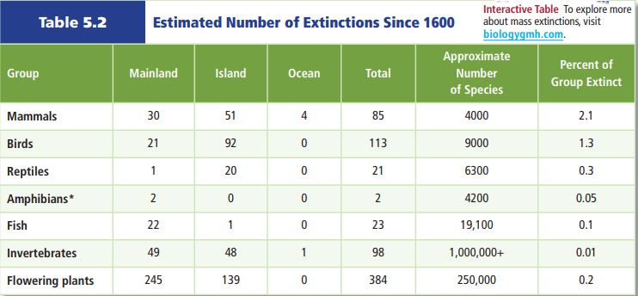
- According to the table above, which of these groups has suffered the smallest percentage loss due to extinction?
- Why are non-native species introductions potentially so dangerous to island organisms?
- How are today’s high rates of extinction different from past mass extinction events?
- What normally happens after a mass extinction? Why might this not happen after this mass extinction?
- What is overexploitation? How does it affect biodiversity?
- How can disruption of a habitat be as harmful as destruction of a habitat?

- Describe how habitat fragmentation can lead to edge effects (describe edge effects as part of your answer).
- What causes eutrophication? What are the problems associated with eutrophication?
- Why are introduced species a threat to biodiversity in their new habitat, but not their original habitat?
- What conclusion can be made based on this graph?
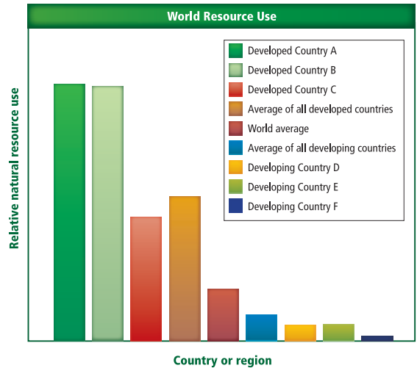
- What is the difference between renewable and nonrenewable resources? Give two examples of each.
- Based on the graph below, how long does it take an area to recover from a landslide?
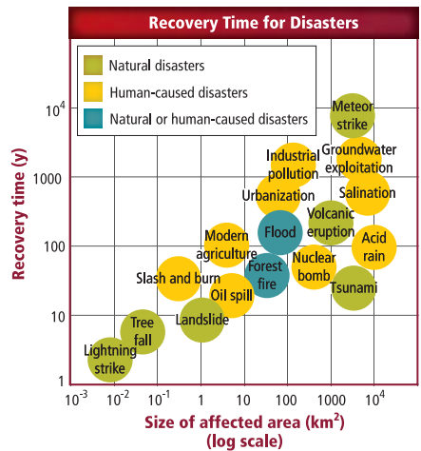
- Based on the graph above, what has the greatest influence on disaster recovery time?
- Choose a human-caused disaster from the graph above. Discuss the methods that could be used to restore biodiversity.
- Read the article on page 136 and what Wangari Maathai did in Kenya and how it has positively impacted her country.

BIOLOGY 2022-23 LAB ACTIVITY
DESIGN YOUR OWN How Does Your Biome Grow
The environmental factors that affect the growth of an organism can be grouped into two categories—biotic and abiotic. Biotic factors are living organisms in the environment. Abiotic factors include naturally occurring substances in the soil, such as chemicals and nutrients, as well as water, sunlight, and temperature. In this lab, you will create a model biome and study the effects of abiotic factors on germinating plants.

Problem
What impact do abiotic factors have on biomes?

Objectives
• Form a hypothesis about the impact of abiotic factors on a biome.
• Design an experiment to test your hypothesis.
• Identify a control to the experiment.
• Make a model of a biome.
• Create a data table.
• Draw conclusions.
Safety Precautions
Wash your hands thoroughly with soap and water after handling the soil.
Possible Materials

bicarbonate of soda tablets
clear plastic bottles (2-L soda bottles)
clear plastic wrap
colored gels or mylar
electric fan
flower seeds
grass seeds
lima bean seeds
index cards
lamps
masking tape
sterile potting soil
alternative soil types (sand, clay, loam)
scissors
small rocks
small beaker or test tubes
tape
water

Hypothesis
Use what you know about ecosystems and ecology to write a hypothesis indicating the effect of an abiotic factor of your choice on the germination of plants in a model biome.
Plan the Experiment
1. Read and complete the lab safety form.
2. Choose which biome you wish to simulate. Be sure that your biome is indicated in your hypothesis.
3. Decide on a procedure to use to test the impact of an abiotic factor on your simulated biome.
4. Identify the independent variable, dependent variable, constants, and control group.
5. Describe how you will measure and record your data.

Check the Plan
1. Make sure your teacher has approved your experimental plan before you proceed.
2. Be sure that a control group is included in your experiment and that the experimental group varies in only one way.
3. Observe and record the impact of abiotic factors on the biotic components of your simulated biome. Be sure to make sketches each day of your biome and the changes you observe. Be detailed in your drawings. Provide quantitative observations (using measurements).
4. When you have completed the experiment, ask your teacher whether you should continue to make long-term observations or dispose of the organisms as he or she directs.

Record the Plan
In the space below, write your experimental procedure and make a sketch of your experimental design.
Data and Observations
1. Use the space below to create a data table of your findings.

Analyze and Conclude
1. On which abiotic factor did you focus? Why?
2. Did this abiotic factor seem to have a significant impact on the dependent variable in your simulated ecosystem? Explain.
3. Describe the control in your experiment. What was held constant in the control? Why was it set up that way?
4. How does your experiment relate to biomes and abiotic factors in nature?
5. Error Analysis What are some possible sources of error in your experiment?
6. Exchange your procedure and data with another group in your class. What do their data show about the biome they chose to simulate? What conclusions can you draw about the abiotic factors in a biome?
7. What are the limitations of the design of this experiment? Are there additional factors at work?

Write and Discuss
Write a short paragraph describing your findings and indicating whether or not they support your hypothesis. Discuss any questions your results have raised.

Inquiry Extensions
1. Describe the rainfall pattern and abiotic factors that make up the biome you live in. How do these factors impact the plants, animals, and agriculture in your area?
2. If you were to maintain your biomes in the classroom or at home, what abiotic factors would you change from your original model? Make a prediction about what you would observe under the new conditions

