BIOLOGY 2022-23 April 20, 2023

Today’s Agenda (Day 148)

- HOUSEKEEPING ITEMS

- Homework Check:
ACTIVITY: Identify Bacteria
- Class Activity:

TEST: Ch 30 – 31

HOMEWORK:
- READ: Chapter 30 – Mammals
- READ: Chapter 31 – Animal Behaviour
- COMPLETE:
- STUDY: Chapter 30 - 31 Test

REMINDERS:

- TEST: Ch 30 - 31 April 20
- QUIZ: Ch 30 - 32 Vocabulary May 4
- TEST: Ch 32 May 9
- TEST: Ch 33 May 11
- QUIZ: Ch 33 & 34 Vocabulary May 18
- TEST: Ch 34 May 25
- QUIZ: Ch 35 Vocabulary May 30
- TEST: Ch 35 May 30 JUNE 1
- QUIZ: Ch 36 Vocabulary June 6
- TEST: Ch 36 June 8

Chapter 30 - Mammals

Cerebellum | Cerebral cortex | Diaphragm | Gestation | Gland | Mammary gland
Marsupial | Monotreme | Placenta | Placental mammal | Therapsid | uterus

Chapter 31 – Animal Behavior

Agonistic behavior | Altruistic behavior | Behavior | Circadian rhythm | Classical conditioning | Cognitive behavior
Courting behavior | Dominance hierarchy | fixed action pattern | Foraging behavior | habituation | Imprinting
Innate behavior | Language | Learned behavior | Migratory behavior | Nurturing behavior | Operant conditioning
Territorial behavior

Chapter 32 Integumentary, Skeletal and Muscular Systems
Actin | Appendicular skeleton | Axial skeleton | Cardiac muscle | Compact bone | Dermis
Epidermis | Hair follicle | Involuntary muscle | Keratin | Ligament | Melanin
Myofibril | Myosin | Ossification | Osteoblast | Osteoclast | Osteocyte
Red bone marrow | Sarcomere | Sebaceous gland | Skeletal muscle | Smooth muscle | Spongy bone
Tendon | Voluntary muscle | Yellow bone marrow

BIOLOGY 2022-23 READING GUIDE

CH 32 Integumentary, Skeletal, & Muscular System
Review pages 936 – 951 in the Glencoe Science Biology Textbook and answer the following questions.

- What four types of tissue make up the integumentary system?
- List AND describe the two layers of skin shown in the picture below.
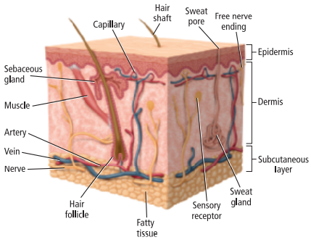
- Describe the structure of the epidermis.
- Explain the role of keratin in the epidermis.
- Describe the structure of the dermis.
- Explain how hair grows.
- Explain what happens in the picture below if oil, dirt, and/or bacteria become trapped in the follicles.
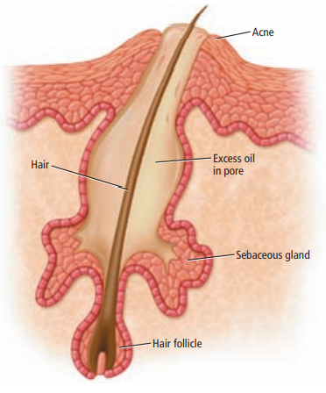
- List AND describe three functions of the integumentary system.
- Describe how skin heals from cuts and scrapes.
- Describe how skin cancer is caused.
- Explain the difference between the axial skeleton and the appendicular skeleton.
- Compare and contrast compact bone and spongy bone.
- Compare and contrast red and yellow bone marrow.
- Describe how bones are formed.
- Describe how bones are remodeled.
- Explain what is happening in the fractured bone below.
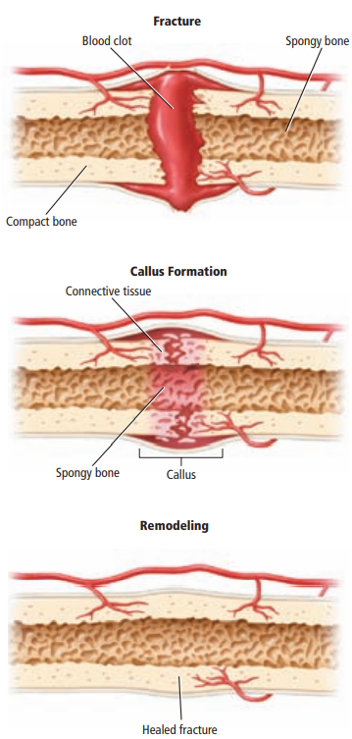
- Explain the role of ligaments in our skeletal system.
- List AND describe five functions of the skeletal system.
- List AND describe the three types of muscle.
- Explain the function of tendons in our muscular system.
- What is the relationship between the following terms: myofibrils, myosin, actin, and sarcomere?
- Explain what is illustrated below.
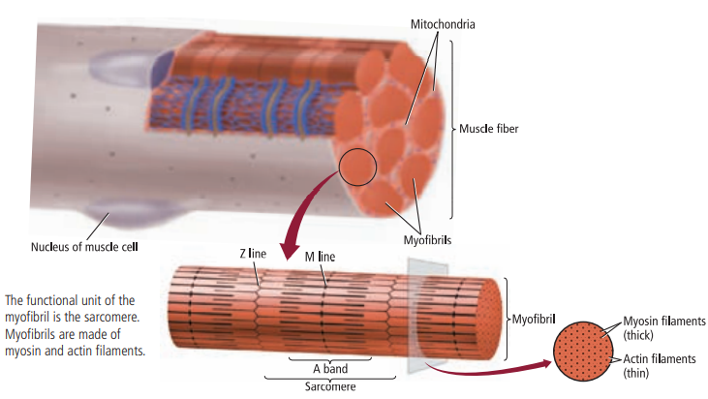
- Where does the energy for muscle contraction come from?
- Compare and contrast slow-twitch and fast-twitch muscles.

