BIOLOGY 2022-23 April 13, 2023

Today’s Agenda (Day 143)

- HOUSEKEEPING ITEMS

- Homework Check:
ACTIVITY: Identify Bacteria
- Class Activity:
TEST: Ch 20
MONDAY: Chapter 30 PPT Review
- Section 30.1 – Mammalian Characteristics
- Section 30.2 – Diversity of Mammals

HOMEWORK:
- READ: Chapter 30 - Mammals
- COMPLETE:
- STUDY: Chapter 30 - 31 Test

REMINDERS:

- TEST: Ch 20 April 11 13
- TEST: Ch 30 - 31 April 18
- QUIZ: Ch 30 - 32 Vocabulary April 20
- TEST: Ch 32 May 4
- TEST: Ch 33 May 9
- QUIZ: Ch 33 & 34 Vocabulary May 11
- TEST: Ch 34 May 23
- QUIZ: Ch 35 Vocabulary May 25
- TEST: Ch 35 May 30
- QUIZ: Ch 36 Vocabulary June 1
- TEST: Ch 36 June 6

Chapter 20 - Fungi

Ascocarp | Ascospore | Ascus | Basidiocarp | Basidiospore | Basidium
Bioindicator | Chitin | Conidiophore | Fruiting body | Gametangium | Haustorium
Hypha | Lichen | Mycelium | Mycorrhiza | Rhizoid | Septum
Sporangium | Spore | Stolon

Chapter 30 - Mammals

Cerebellum | Cerebral cortex | Diaphragm | Gestation | Gland | Mammary gland
Marsupial | Monotreme | Placenta | Placental mammal | Therapsid | uterus

Chapter 31 – Animal Behavior

Agonistic behavior | Altruistic behavior | Behavior | Circadian rhythm | Classical conditioning | Cognitive behavior
Courting behavior | Dominance hierarchy | fixed action pattern | Foraging behavior | habituation | Imprinting
Innate behavior | Language | Learned behavior | Migratory behavior | Nurturing behavior | Operant conditioning
Territorial behavior

Chapter 32 Integumentary, Skeletal and Muscular Systems
Actin | Appendicular skeleton | Axial skeleton | Cardiac muscle | Compact bone | Dermis
Epidermis | Hair follicle | Involuntary muscle | Keratin | Ligament | Melanin
Myofibril | Myosin | Ossification | Osteoblast | Osteoclast | Osteocyte
Red bone marrow | Sarcomere | Sebaceous gland | Skeletal muscle | Smooth muscle | Spongy bone
Tendon | Voluntary muscle | Yellow bone marrow

BIOLOGY 2022-23 READING GUIDE
Chapter 20 Reading Guide
- Describe characteristics shared by all fungi. How many species of fungi are known today?
- Compare and contrast multicellular fungi and unicellular fungi.
- Describe two ways the physical structure of a fungi differs from that of a plant.
- Compare and contrast the two types of hyphae shown below.
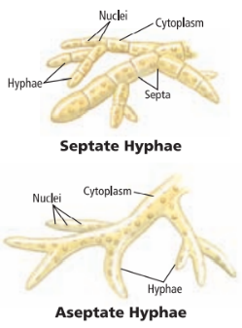
- Compare and contrast saprophytic fungi and mutualistic fungi. Give one example of each type.
- What is a fairy ring? Why do fairy rings form?
- List and describe three different methods fungi use to reproduce.
- Describe three different adaptations fungi use for survival.
- What is illustrated in the diagram below?
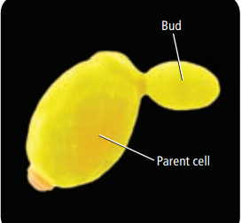
- Describe the life cycle of the common mold shown below.
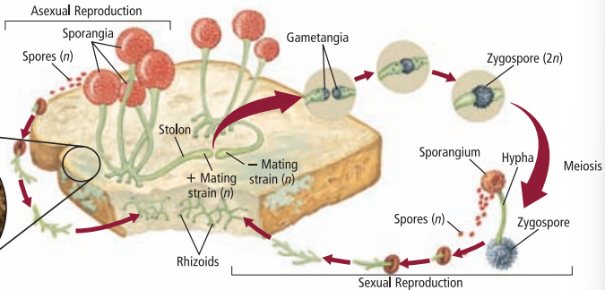
- Describe the life cycle of sac fungi.
- Describe the life cycle of club fungi.
- What is mutualism? Give an example.
- What is a lichen?
- How do lichens survive a severe drought?
- What is a bioindicator? Why are lichens considered to be bioindicators?
- Describe two examples of beneficial fungi.
- What role does fungi play in food production for humans?
- What is bioremediation? How are fungi useful in terms of bioremediation?
- Describe two examples of harmful fungi.

BIOLOGY 2022-23 READING GUIDE

CH 30 Mammals Reading Guide
Review pages 880 – 897 in the Glencoe Science Biology Textbook and answer the following questions.
- List and describe two characteristics that distinguish members of class Mammalia.
- Describe six different functions of hair.
- List five other characteristics shared by mammals (other than the ones from the first question).
- Explain what is depicted below.
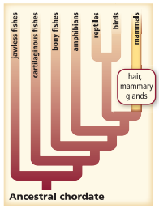
- List, describe, AND give an example of four trophic categories that mammals fit into.
- Describe digestion in ruminant herbivores.
- Describe how mammalian teeth are indicative of their diet.
- Explain the picture below.
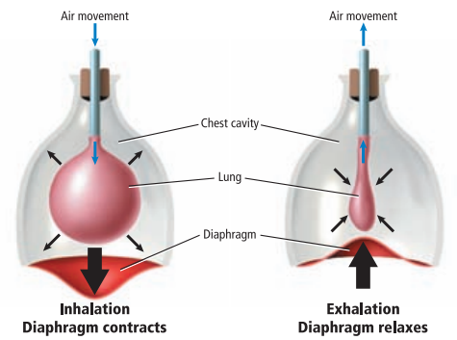
- Explain the image below.
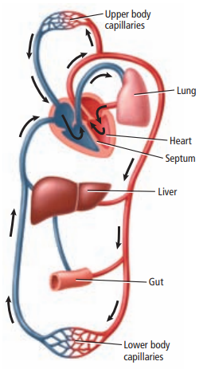
- Describe the functions of the cerebral cortex and the cerebellum.

- Define the term gland AND give two different examples of unique mammalian glands.

- Describe the role of the uterus and placenta in mammalian reproduction.

- Compare the gestation period of a Virginian opossum and an African elephant.

- Describe general characteristics shared by monotremes.

- Describe general characteristics shared by marsupials.

- Describe general characteristics shared by placental mammals.

- Compare and contrast order Insectivora and order Chiroptera AND give an example of each.

- What order do each of the following mammals belong to?
a. Seals
b. Humans
c. Rabbits
d. Sheep
e. Elephants
f. Rhinos
g. Dolphins
h. Manatees
i. Bears
j. Anteaters

- Describe what is illustrated below.
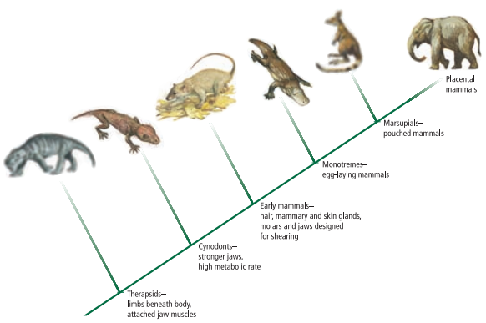
- Describe what scientists think the first mammals were like.

BIOLOGY 2022-23 READING GUIDE

CH 31 Animal Behavior Reading Guide
Review pages 908 – 923 in the Glencoe Science Biology Textbook and answer the following questions.
- Define behavior (include the definition of stimulus in your answer).
- What do most scientists agree upon as the cause of most behaviors?
- Describe the two general questions asked when studying behavior.
- Describe an example of how a behavior can be naturally selected (evolve).
- What are innate behaviors? Give an example.
- What type of behavior is shown below? Describe why the goose does this.
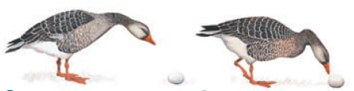
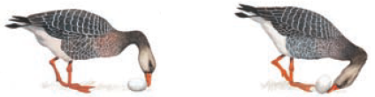
- What is the purpose of the mother bird’s behavior shown below?
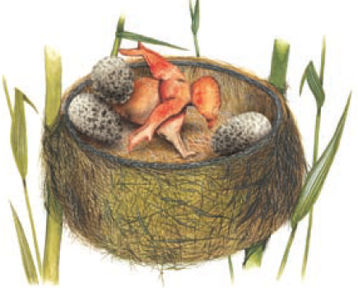
- How do learned behaviors differ from innate behaviors?
- Explain habituation. Give an example.
- Compare and contrast classical conditioning and operant conditioning.
- Explain the experiment shown below.
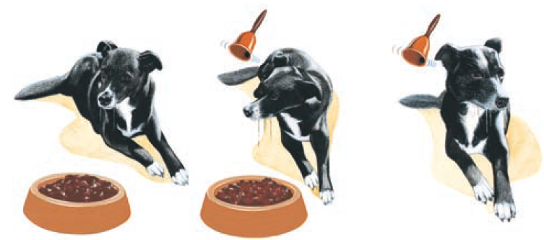
- Give an example of operant conditioning.
- Explain imprinting and give an example.
- What are cognitive behaviors? Name two animals that exhibit cognitive behaviors.
- List AND describe three types of competitive behaviors.
- What are foraging behaviors? Give an example.
- How do migratory behaviors increase the likelihood of survival?
- What are circadian rhythms? Explain what influences these rhythms.
- Explain the diagram below.
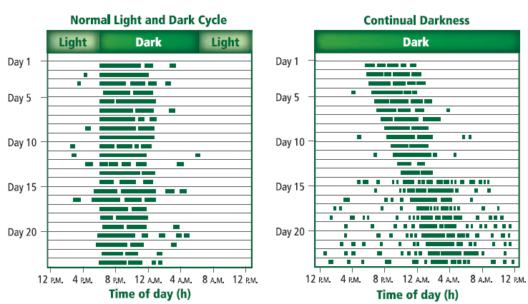
- List and describe two types of communication behaviors used by animals.
- What are courting behaviors? Give an example.
- What are nurturing behaviors? Give an example.
- What are altruistic behaviors? Give an example.
- Describe one theory that explains altruistic behavior.

BIOLOGY 2022-23 READING GUIDE

CH 32 Integumentary, Skeletal, & Muscular System
Review pages 936 – 951 in the Glencoe Science Biology Textbook and answer the following questions.

- What four types of tissue make up the integumentary system?
- List AND describe the two layers of skin shown in the picture below.
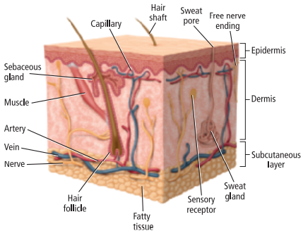
- Describe the structure of the epidermis.
- Explain the role of keratin in the epidermis.
- Describe the structure of the dermis.
- Explain how hair grows.
- Explain what happens in the picture below if oil, dirt, and/or bacteria become trapped in the follicles.
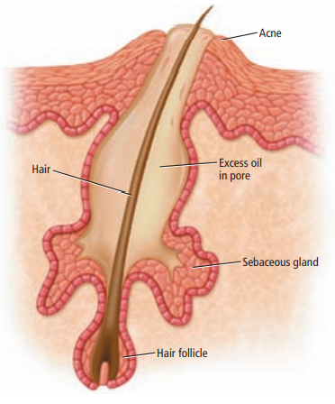
- List AND describe three functions of the integumentary system.
- Describe how skin heals from cuts and scrapes.
- Describe how skin cancer is caused.
- Explain the difference between the axial skeleton and the appendicular skeleton.
- Compare and contrast compact bone and spongy bone.
- Compare and contrast red and yellow bone marrow.
- Describe how bones are formed.
- Describe how bones are remodeled.
- Explain what is happening in the fractured bone below.
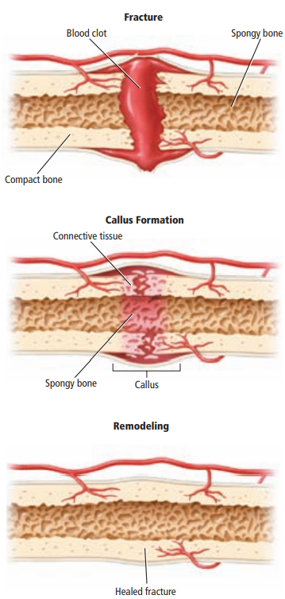
- Explain the role of ligaments in our skeletal system.
- List AND describe five functions of the skeletal system.
- List AND describe the three types of muscle.
- Explain the function of tendons in our muscular system.
- What is the relationship between the following terms: myofibrils, myosin, actin, and sarcomere?
- Explain what is illustrated below.
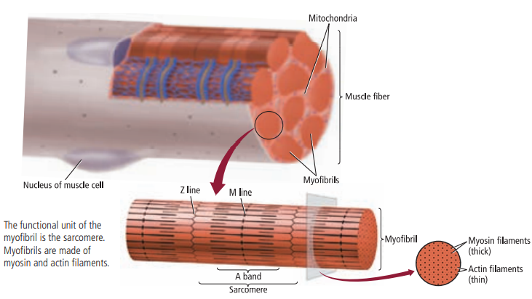
- Where does the energy for muscle contraction come from?
- Compare and contrast slow-twitch and fast-twitch muscles.

