BIOLOGY 2022-23 March 31, 2023

Today’s Agenda (Day 136)

- HOUSEKEEPING ITEMS

- Homework Check:

- Class Activity:
ACTIVITY: Identify Bacteria
DAY3: Chapter 19 PPT Review
- Section 19.4 – Funguslike Protists

HOMEWORK:
- READ: Chapter 19 - Protists
- COMPLETE:
- STUDY: Chapter 19 & 20 Vocabulary Quiz AND Chapter 19 Test

REMINDERS:

- TEST: Ch 19 April 4
- TEST: Ch 20 April 6
- TEST: Ch 30 - 31 April 13
- QUIZ: Ch 32 Vocabulary April 18
- TEST: Ch 32 April 20
- TEST: Ch 33 May 4
- QUIZ: Ch 33 & 34 Vocabulary May 9
- TEST: Ch 34 May 11
- QUIZ: Ch 35 Vocabulary May 23
- TEST: Ch 35 May 25
- QUIZ: Ch 36 Vocabulary May 30
- TEST: Ch 36 June 1

Chapter 19 - Protists

Acrasin | Alternation of generations | Bioluminescent | Colony | Contractile vacuole | Microsporidium
Pellicle | Plasmodium | Protozoan | Pseudopod | Test | trichocyst

Chapter 20 - Fungi

Ascocarp | Ascospore | Ascus | Basidiocarp | Basidiospore | Basidium
Bioindicator | Chitin | Conidiophore | Fruiting body | Gametangium | Haustorium
Hypha | Lichen | Mycelium | Mycorrhiza | Rhizoid | Septum
Sporangium | Spore | Stolon

BIOLOGY 2022-23 Activity

Identifying Bacteria

OVERVIEW Scientists can identify bacteria by observing their physical and chemical characteristics. In this activity you will practice identifying bacteria based on four characteristics: Gram stain, cell shape, arrangement, and motility.
GRAM STAIN The Gram stain is a method of sorting bacteria into two groups based on the composition of the cell wall. The Gram stain detects the amount of peptidoglycan in the cell wall. Cells with high amounts of peptidoglycan are stained dark purple and are called “Gram-positive” cells. Cells with only a small amount of peptidoglycan will appear light pink and are called “Gram-negative” cells.
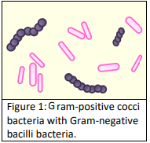
CELL SHAPE AND ARRANGEMENT Bacteria come in a variety of shapes. The most common bacterial shapes are spherical (cocci), rod-shaped (bacilli), and spiral (spirilli). Cocci are typically arranged as single individuals, pairs, chains, or clusters. Bacilli can be arranged as single individuals, pairs, or chains. Spirilli usually occur as single individuals and can be found in two forms. Spirillum are rigid and evenly spiraled while spirochetes are flexible and can twist unevenly.
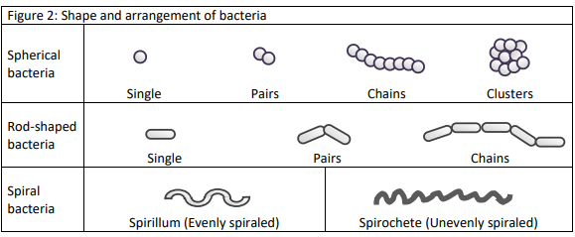
MOTILITY Some bacteria do not move, but others can move towards stimuli using one or more flagella. Cocci typically lack flagella. Single bacilli and some spirilli can have one or more flagella.

Bacteria Identification Data Sheet
Use the dichotomous key to identify the 12 bacterial species provided. Record the scientific name and a short description of each species in the table below.

Bacteria | Specific Name | Description
A | Klebsiella pneumoniae | Gram-negative, bacillus, no flagella, present as single individuals.
B
C
D
E
F
G
H
I
J
K
L

Bacteria Dichotomous Key Use the dichotomous key below to identify the 12 bacterial species provided. Begin with Step 1 and continue as directed. Read each characteristic carefully. Once you have determined the scientific name of the bacteria, record your results in the data table.
Bacteria | Characteristic | Description
1 | 1a. Gram-positive… go to step 2  1b. Gram-negative… go to step 6
2 | 2a. Bacilli… go to step 3  2b. Cocci… go to step 4
3 | 3a. Arranged in chains…………….…………………..…..  3b. Present as single individuals……………………… | Bacillus cereus  Clostridium botulinum
4 | 4a. Arranged in pairs or chains… go to 5  4b. Arranged in clusters………………………………….… | Staphylococcus aureus
5 | 5a. Arranged in pairs…………………………………………  5b. Arranged in chains…………………………….……….. | Streptococcus pneumoniae  Streptococcus pyogenes
6 | 6a. Spirilli … go to step 7  6b. Bacilli or Cocci… go to step 8
7 | 7a. Spirillum with flagella……………………….…………  7b. Spirochete without flagella…….….……………… | Spirillium voltans  Leptospira interrogans
8 | 8a. Bacilli… go to step 9  8b. Cocci arranged in pairs………………….…………... | Neisseria gonorrhoeae
9 | 9a. Present as single individuals… go to step 10  9b. Arranged in pairs or chains... go to step 11
10 | 10a. Have flagella…………………………………………….  10b. Do not have flagella………………………………… | Salmonella enterica  Klebsiella pneumoniae
11 | 11a. Arranged in pairs………………………………………  11b. Arranged in chains……………………………………. | Moraxella lacunata  Streptobacillus moniliformis

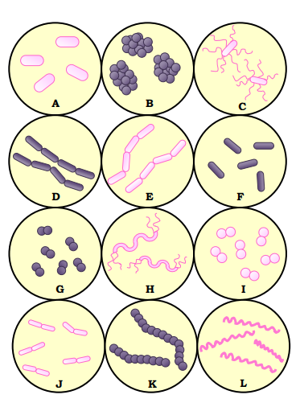

BIOLOGY 2022-23 READING GUIDE
Chapter 19 Reading Guide
Review pages 542 – 565 in the Glencoe Science Biology Textbook and answer the following questions.
- How are protists classified? What is the one trait all protists share?
- List and describe the three different methods protists use to obtain nutrition.
- Describe a typical habitat for a protist.
4. How do ciliophora move?
5. Describe the structure of a paramecia. (Include all vocabulary on page 547)
- Compare and contrast binary fission and conjugation as forms of reproduction for ciliates.
- Describe the structure of an amoeba.
- What do amoebas use cysts for?
- Describe three characteristics shared by all sporozoans.
- List and describe a disease caused by sporozoans that are members of the genus Plasmodium.
- Describe common traits shared by zooflagellates.
- Why are algae considered to be plant-like?
- What are diatoms? How do they reproduce?
- What does bioluminescent mean? Name a bioluminescent insect (it isn’t in the book).
- What are red tides? Why are red tides potentially so dangerous?
- Compare and contrast brown algae and green algae.
- List and describe three uses of algae.
- Describe what is meant by alternation of generations (be sure to include haploid and diploid in your answer).
- Describe common characteristics shared by slime molds.
- Compare and contrast acellular slime molds and cellular slime molds.
- What impact has downy mildew had on the history of the United States?
BIOLOGY 2022-23 READING GUIDE
Chapter 20 Reading Guide
- Describe characteristics shared by all fungi. How many species of fungi are known today?
- Compare and contrast multicellular fungi and unicellular fungi.
- Describe two ways the physical structure of a fungi differs from that of a plant.
- Compare and contrast the two types of hyphae shown below.
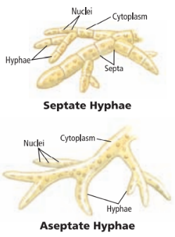
- Compare and contrast saprophytic fungi and mutualistic fungi. Give one example of each type.
- What is a fairy ring? Why do fairy rings form?
- List and describe three different methods fungi use to reproduce.
- Describe three different adaptations fungi use for survival.
- What is illustrated in the diagram below?
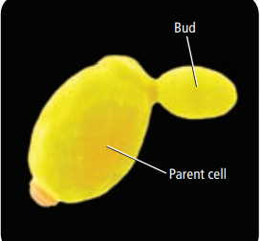
- Describe the life cycle of the common mold shown below.
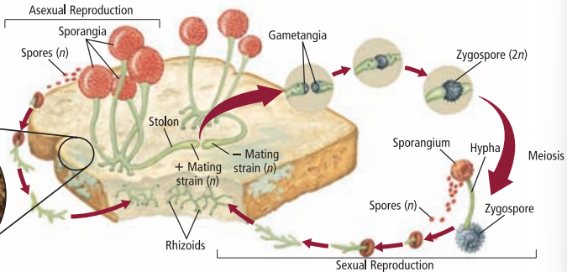
- Describe the life cycle of sac fungi.
- Describe the life cycle of club fungi.
- What is mutualism? Give an example.
- What is a lichen?
- How do lichens survive a severe drought?
- What is a bioindicator? Why are lichens considered to be bioindicators?
- Describe two examples of beneficial fungi.
- What role does fungi play in food production for humans?
- What is bioremediation? How are fungi useful in terms of bioremediation?
- Describe two examples of harmful fungi.

