BIOLOGY 2022-23 March 1, 2023

Today’s Agenda (Day 115)

- HOUSEKEEPING ITEMS

- Homework Check:
Ch 14 Reading Guide
- Class Activity:
SCIENCE FAIR COUNTDOWN – 2 days to competition!
*PRESENTATIONS: Mock

THURSDAY: UPON RETURN FROM BREAK: CONT’D: PRESENTATION: How Many CATs – DNA Profiling Simulation

HOMEWORK:
- READ: Chapter 15 - Evolution
- COMPLETE: SF Report and Poster Board Final
- STUDY: Chapter 15 Test

REMINDERS:

- TEST: Ch 15 Tuesday, Mar. 7

Chapter 15 – Evolution

Adaptive radiation | Allopatric speciation | Analogous structure | Ancestral trait | Artificial selection | Biogeography
Bottleneck | Camouflage | Derived trait | Directional selection | Disruptive selection | Embryo
Evolution | Fitness | Founder effect | Genetic drift | Gradualism | Hardy-Weinberg principle
Homologous structure | Mimicry | Natural selection | Post-zygotic isolating mechanism | Pre-zygotic isolating mechanism | Punctuated equilibrium
Sexual selection | Stabilizing selection | Sympatric speciation | Vestigial structure
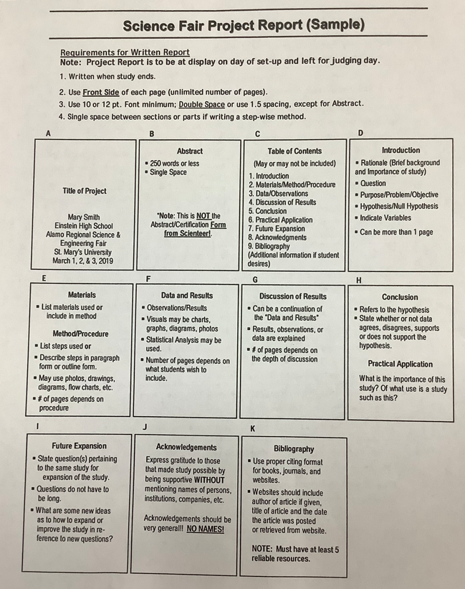

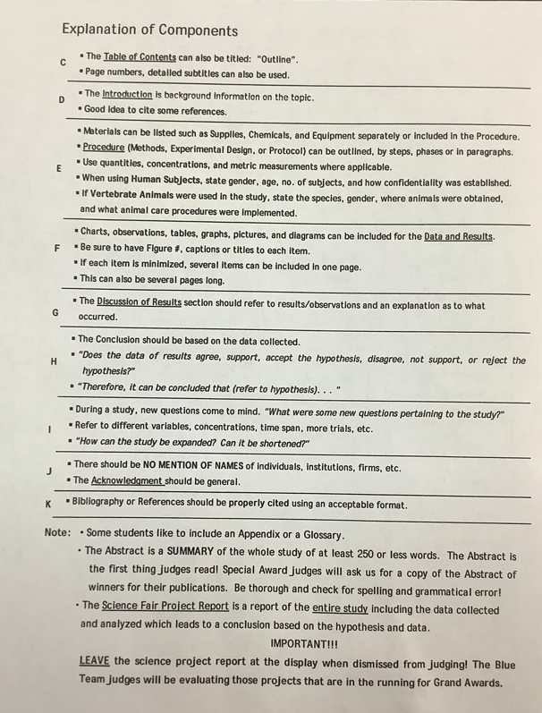
BIOLOGY 2022-23 READING GUIDE
Chapter 15 Evolution

DIRECTIONS: Refer to your textbook to respond to the following questions.

- What did Darwin suspect happen to species on the Galapagos Islands?
- What did Thomas Malthus suggest would happen to the human population?
- How did Darwin take Malthus’ ideas to help describe what he had seen in the Galapagos Islands?
- Describe the process of natural selection.
- Darwin’s theory of evolution by natural selection has four basic principles that explain how traits of a population can change over time. List the four principles.
- Define evolution. What is the driving mechanism behind evolution?
- How does the fossil record provide evidence to support evolutionary change?
- What is the significance of Archaeopteryx? What organisms did it evolve from?
- Compare derived traits and ancestral traits.
- Explain why all of the bones of human, horse, cat, porpoise, and bat (as shown on p.425 of textbook) share a similar structure? How did they develop different functions?
- Which of the forelimbs mentioned in #10 would most likely resemble a whale’s fin?
- What are vestigial structures?
- How does evolutionary theory predict vestigial structures?
- Eagles and May beetles are not closely related, yet they both have wings. How can this be explained?
- How does comparative embryology provide support for evolutionary theory?
- What does the graph below suggest?

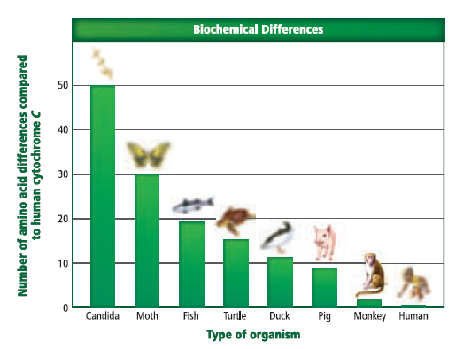
- Would the cytochrome c of a reptile or a bird be expected to have more amino acid differences when compared to that of a human? Explain (use the graph for this question).
- What is an adaptation? How are adaptations related to fitness?
- Compare and contrast camouflage and mimicry.
- Give an example of how an organism uses mimicry to increase its chances of survival.
- How is the helplessness of a human baby a consequence of adaptation rather than an evolutionary advantage?
- Describe what natural selection explains in terms of evolution.
- Explain the Hardy-Weinberg principle.
- How does the Hardy-Weinberg principle help explain the following picture?
- According to the Hardy-Weinberg principle, what are the five conditions that a population in genetic equilibrium must meet to remain that way?
- What is the consequence of a non-random mating population of organisms (according to H-W)?
- What is the consequence of a small population of organisms (according to H-W)?
- Describe the founder effect. Whys is this an example of genetic drift?
- What effect has the bottleneck had on the reproductive rate of cheetahs?
- How can mutations benefit a population?
- List the three main ways in which natural selection alters phenotypes.
- Give an example of stabilizing selection in humans.
- Describe 2 examples of directional selection (don’t just list them).
- Describe one example of disruptive selection.
- How can sexual selection change the frequency of a trait in a population?
- Describe an example of how sexual selection has resulted in a different appearance for males and females of a species.
- Compare and contrast prezygotic and postzygotic isolating mechanisms.
- Describe an example of a prezygotic isolating mechanism.
- Describe an example of a postzygotic isolating mechanism.
- Compare and contrast allopatric speciation and sympatric speciation.
- Describe and provide an example of adaptive radiation.
- Give an example of coevolution and explain why your example illustrates the concept.
- What is the driving force behind convergent evolution?
- Describe an example of convergent evolution.

