BIOLOGY 2022-23 February 14, 2023

Today’s Agenda (Day 109)

- HOUSEKEEPING ITEMS

- Homework Check:

- Class Activity:
Day 40: Science Fair
*CONT’D - Week 4 of your experiment
*Begin SF Report Draft – Due Friday see p. 2 of doc
CONT’D: PRESENTATION: How Many CATs – DNA Profiling Simulation
DAY 2: Chapter 14 PPT Review
- Section 14.1 – Fossil Evidence of Change
- Section 14.2 – The Origin of Life

HOMEWORK:
- READ: Chapter 14 – The History of Life
- COMPLETE: SF Report Draft
- STUDY: Chapter 14 Test
REMINDERS:

- TEST: Ch 14 Thursday, Feb. 16

Chapter 14 – The History of Life

Cambrian explosion | Endosymbiont theory | Eon | Epoch | Era | Fossil
Geologic time scale | Half-life | K-T boundary | Law of superposition | Paleontologist | Period
Plate tectonics | Radiometric dating | Relative dating | Spontaneous generation | Theory of biogenesis

Chapter 15 – Evolution

Adaptive radiation | Allopatric speciation | Analogous structure | Ancestral trait | Artificial selection | Biogeography
Bottleneck | Camouflage | Derived trait | Directional selection | Disruptive selection | Embryo
Evolution | Fitness | Founder effect | Genetic drift | Gradualism | Hardy-Weinberg principle
Homologous structure | Mimicry | Natural selection | Post-zygotic isolating mechanism | Pre-zygotic isolating mechanism | Punctuated equilibrium
Sexual selection | Stabilizing selection | Sympatric speciation | Vestigial structure
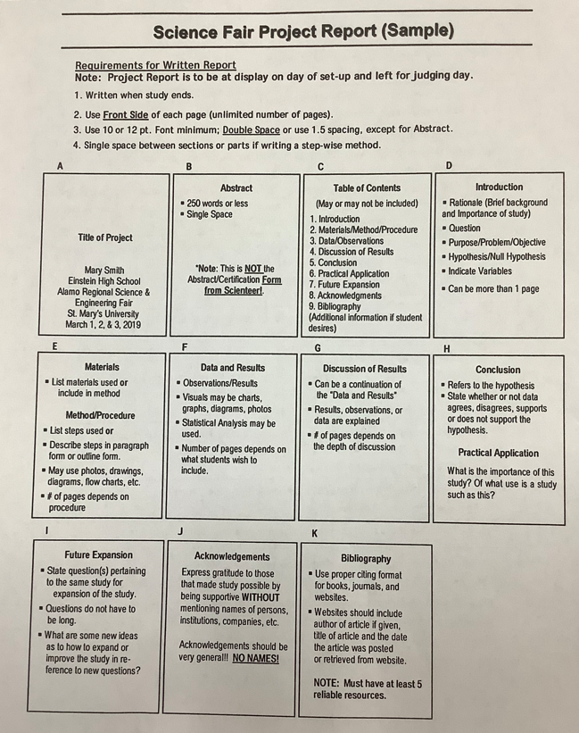

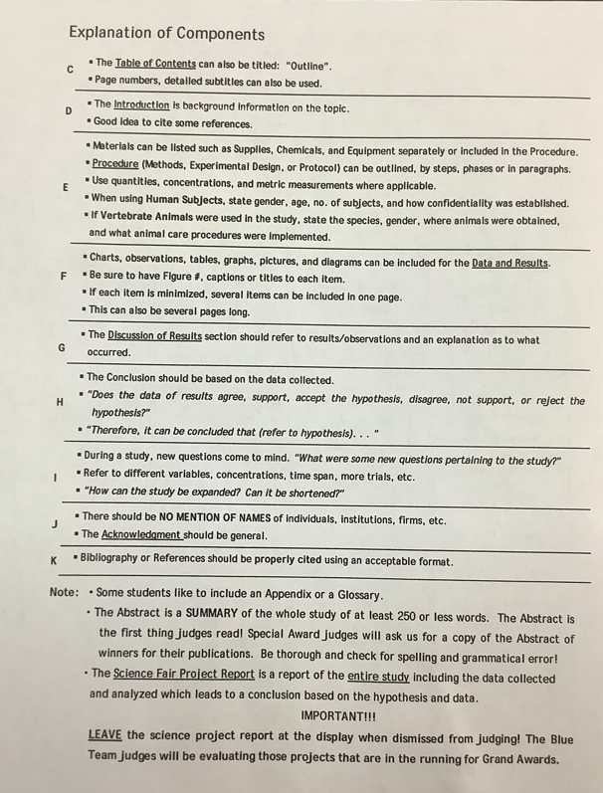
BIOLOGY 2022-23 READING GUIDE

Chapter 14 The History of Life Reading Guide
Review pages 392 - 407 in the Glencoe Science Biology Textbook and answer the following questions.
- Describe the land and the atmosphere on Earth when it formed 4.6 billion years ago.
- Why are there more fossils of organisms that lived in water rather than on land?
- Describe how fossils are formed. (Include the type of rock this process occurs in).
- List the layers in the diagram below from oldest to youngest. What law allows you to make this determination?
- Which layer in the picture above shows that a aquatic ecosystem replaced a land ecosystem? Explain yourself.
- The graph below shows the decay of a carbon isotope. What is its approximate half-life?
- Describe the types of organisms found during the Precambrian Era.
- Describe the types of organisms found during the Paleozoic Era.
- What marked the end of the Paleozoic Era?
- Describe the dominant types of organisms on Earth in the Mesozoic Era.
- How did Francesco Redi provide evidence against spontaneous generation (describe his experiment).
- What is demonstrated in Step C of Pasteur’s experiment shown below?
- Explain the primordial soup hypothesis.
- What was the significance of the Urey-Miller experiment?
- Describe the first cells on Earth.
- Describe how oxygen was added to Earth’s atmosphere.
- Why do you think prokaryotic cells probably appeared before eukaryotic cells?
- Describe the endosymbiont theory. What evidence supports this theory?

BIOLOGY 2022-23 ACTIVITY
How Many CATs? A DNA Profiling Simulation
Objectives
In this lab, you will investigate the technology behind DNA profiling (DNA fingerprinting). During this simulation you will work through the theory of DNA profiling and grapple with some analytical and ethical questions. It will help to reinforce basic concepts such as base pairing in DNA as well as the principles of restriction enzyme digestion, gel electrophoresis, and probe hybridization. From the results of your simulated gel, you will be able to determine the paternity of a child.
Introduction
DNA profiling (also called DNA fingerprinting) is now being used in some criminal and legal cases where DNA samples are available to determine identity or parentage. DNA may be extracted from relatively small samples of cells, such as a blood stain the size of a nickel (about two drops) or a semen stain the size of a dime. When performed under properly controlled conditions and interpreted by an experienced forensic scientist, such profiling can link a suspect to a particular incident with compelling accuracy or completely exonerate a suspect.
At the DNA level individual people are about 99.9% identical; they differ on average in 1 out of 1000 base pairs. Some of these differences are in genes which lead to the visible differences between us. Some of the differences, however, are in “junk” DNA (DNA which as far as is known is not transcribed into RNA). In 1984, Sir Alec Jeffreys discovered short nucleotide sequences (3 to 30 base pairs in length) that were repeated multiple times (10 to 100 times) in non-coding regions of DNA. These are known as Variable Number Tandem Repeats, or VNTRs. In each case, what is variable is the number of copies of the sequence in an allele. So for example, if the repeated sequence were CAT, in one allele there might be 3 copies [CATCATCAT] whereas another allele might have 7 copies [CATCATCATCATCATCATCAT].
In a given population there may be dozens or even hundreds of different VNTR alleles. Of course, any individual has only two alleles, one on each of the homologous chromosomes (one each of which was inherited from one parent). Since there are so many alleles in a population, most people are heterozygous for alleles of any given VNTR. If one examines enough different VNTRs (6 to 12) in a given person, one can put together a molecular picture or “DNA fingerprint” of that person. This can be used for identification of tissue left at the scene of a crime (semen from a rape victim) or for paternity testing, in which case the VNTR alleles in the child that are not present in the mother must have come from the biological father.
The Simulation
The activity simulates the following situation. A married woman has been raped. Her attacker has been identified, tried, and found guilty and is now serving a prison sentence. During the legal proceedings, the woman discovered that she was pregnant. If the child was fathered by her husband, she wanted to have this child. However, if the child was fathered by the rapist, the woman wished to abort the fetus. The woman and her husband agreed to have DNA samples collected from the fetus by amniocentesis, and they both gave samples to the lab. The rapist did not have to voluntarily give a DNA sample because it was obtained from the semen stains on the bed linens which were held as evidence by the police.
Materials (per group of two students):
• large sheet of paper or poster board for gel (at least 60 cm x 80 cm)
• scissors and tape (or glue)
• set of base sequences representing the “Standards,” “Mother DNA,” “Child DNA,” “Suspect DNA,” and “Husband DNA”
• set of “Probe” sequences copied onto brightly colored paper
Procedure
1. Cut out the strips of DNA sequences for each of the individuals and the standards. Be sure to keep each individual’s DNA strands separate from each other’s.
2. We will be using the restriction endonuclease Hind III. Mark the sample strip at the recognition sites for the restriction enzyme (AAGCTT) and cut the strip all the way across between the two A’s of each restriction site.
3. Use the desktop or a large sheet of newsprint to simulate the gel electrophoresis apparatus. The standards should be placed first. Use the top of the desk or paper to represent the wells of the gel. Exact distances from the origin in the “well” are not important, as long as all fragments of the same length are placed the same distance from the well. The larger fragments are placed closest to the well with the smaller ones being placed further away in descending order beneath the well. The standards should span almost the whole distance, leaving perhaps 5 cm at the bottom.
4. Place the fragments of the mother’s sample to the right of the standard sample well. Note that the mother’s 12-base fragment should be the same distance from its well as the standard 12-base fragment is from its well.
5. Continue placement of the remaining samples in the same manner, moving to the right across the paper or desk top in the following order: husband, suspect and child. When complete, each sample should contain five different fragments.
6. On a separate sheet of paper, sketch the results of this electrophoresis event. Remember that in “real life” these fragments would be invisible to the naked eye.
7. These fragments must next be differentiated from one another by use of the “probe.” Construct DNA probes by cutting the simulated fluorescent probes from the brightly colored paper containing the probe sequences. These DNA probes will be used to see (“visualize” as the scientists call it) the VNTR sequences. (Remember that the probe sequence, 3'GTAGTA5', is complementary to the VNTR sequences, 5'CATCAT3'. With a probe in hand, scan the “gel” and position a probe on each complementary sequence. Each labeled fragment represents a part of one chromosome of a homologous pair.
8. On your previous sketch of the unmarked gel, identify the fluorescently marked fragments by lightly coloring over them with a colored pencil.
Analysis and Discussion (Answer the following on a separate sheet of paper.)
1. Sketch the electrophoresis gel before and after the addition of the radioactive probes. In the “before” diagram, use a regular pencil to sketch the fragments. In the “after” sketch, use a colored pencil to show the bands that showed up with the probe.
2. Discuss the results of the DNA gel you made in class. Analyze the banding patterns according to Mendelian principles: the child inherited one allele from each parent. In our example, the mother donated one of the child’s labeled alleles. Which man is more likely to have donated the other allele? Which of the two men was most likely the father of the child? Explain the reason for this answer. How sure can you be? What other procedures could you have done to be more certain?
3. DNA profiles from two suspects (SA and SB) are shown below along with evidence (E) found at a murder scene (a blood drop). The marker (M) is shown for reference of sizes. Based on the results shown, which of the two will be most likely exonerated in this case? Explain your conclusion.

M | E | SA | SB
___ |  | ___
 | ___ |  | ___
___
___
___ | ___ |  | ___
 |  | ___
___
4. For each of the following scenarios, discuss the implications of DNA analysis on the outcome(s). Also, think and discuss the bioethics involved in some of these cases. There are no right or wrong answers in this section.
• Suppose a pregnant 14-year-old claimed the pregnancy resulted from her father raping her and he claimed her boyfriend was the father. Could this procedure be used?
• What if the samples represented two suspects in the rape instead of the husband and suspect, and a stain from the woman’s clothing instead of a fetus? Would this be sufficient evidence to convict (or exonerate) a suspect of the crime?
• Could blood on the clothes of a murder suspect be used to implicate him in the crime?
• On occasion, pediatricians have been asked by a husband to test his baby to determine if he is really the father, but without informing the mother. What should the doctor do?
• The U.S. military has just instituted a policy of taking and freezing a blood sample from each recruit. If necessary, the frozen sample will be subjected to DNA profiling (e.g. to identify remains). Do you agree with this policy?
• The Tomb of the Unknown Soldier in Washington, DC contains the remains of soldiers from different branches of the armed services. The parents of one of the Marines assumed missing in action during the Vietnam War had evidence to believe that their son was one of the Unknowns buried. There was also evidence from the government. The remains were exhumed and tested using DNA profiling techniques; it turns out that it was indeed their son. The parents are planning to remove the remains and bury them in their hometown. Do you think this test should have been done?
• Some states like California mandate that all men convicted of sex felonies give a blood sample for DNA profiling before they are released from prison. The information is stored on a computer. When a sex crime occurs in the state, a DNA profile will be run on the evidence and run on computer to check whether a match exists with the DNA of a previous convict. New York State has proposed do likewise. What do you think?
• What limitations can be seen in these procedures?
5. Find an article from the popular press in which DNA profiling was used for whatever reason. Attach the article to your answer paper. Read the article and then assess the validity of the report. Try to pick out errors as well as correct points. In criminal cases, do you believe that a “jury of your peers” would be intelligent enough to understand this forensic evidence?

