AP PSYCHOLOGY 2022-23 August 19, 2022

Today’s Agenda (Day 3)

- HOMEWORK CHECK

- Class Activity:
Icebreaker
- Crazy Handshake

REVIEW: APA vs. MLA
Practice: https://content.bridgepointeducation.com/curriculum/file/442a99d8-8b99-4c2a-925f-71869c7dc324/1/In-Text%20Citation%20Practice%20Quiz.zip/story_html5.html

HOMEWORK:
- !Nothing yet! Enjoy!

REMINDERS:
- Return signed/completed forms: August 19, 2022
- Contact Form
- Student Handbook Form
- BYOD Form
- APs/Electives
- Teacher Contact Info: sbeland@luschool.com
msbeland.weebly.com

AP PSYCHOLOGY 2022-23 ACTIVITY

APA REFERENCING EXERCISES

Work individually or with a partner/group.

In-text Referencing
Find and correct the errors in the following in-text citations according to APA referencing conventions.
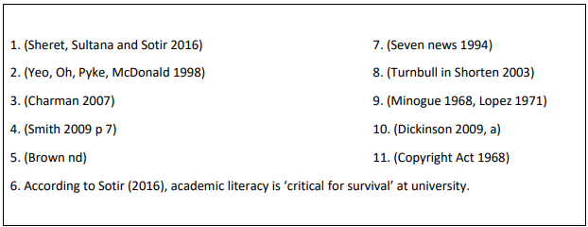

Reference Lists
Find and correct the errors in this reference list according to APA referencing conventions.

