**AP BIOLOGY 2019-20 December 6, 2019**

**Today’s Agenda (Day 69)**

1. HOUSEKEEPING:

🡪

1. Homework Check:

🡪 Virtual Lab: Plant Pigment & Photosynthesis AND Transpiration

Make notes on Key Concepts. Complete and record Analysis of Results and Lab Quiz.

🡪 Chapter 15 & 16 Vocabulary

🡪 Lab Report: Potato Enzyme

🡪 Lab Report: Photosynthesis

🡪 Chapter 15 Notes

🡪 Chapter 16 Notes

1. Class Activity:

🡪 **BEGIN: Chapter 15 PPT Review**

1. **Section 15.2 – Sex-linked genes exhibit unique patterns of inheritance**
2. Section 15.3 – Linked genes tend to be inherited together because they are located near each other on the same chromosome
3. Section 15.4 – Alterations of chromosome number or structure cause some genetic disorders
4. Section 15.5 – Some inheritance patterns are exceptions to standard Mendelian inheritance

HOMEWORK:

* Read Unit 4 Chapters on Genetics: Chapters 15 – 16
* Complete Lab Reports Various
* Study for Chapter 15 & 16 Vocabulary Quiz AND Test

Chapter 15 – Chromosomal Basis of Inheritance

|  |  |  |  |  |  |
| --- | --- | --- | --- | --- | --- |
| aneuploidy | Barr body | chromosome theory of inheritance | Deletions | Down syndrome | duplications |
| genomic imprinting | Inversions | linkage map | linked genes | monosomy | nondisjunction |
| parental types | Polyploidy | recombinant types | sex-linked genes | Translocations | trisomy |

Chapter 16 – Molecular Basis of Inheritance

|  |  |  |  |  |  |
| --- | --- | --- | --- | --- | --- |
| Antiparallel | DNA ligase | DNA pol I | DNA pol III | DNA replication | double helix |
| Euchromatin | Helicase | Heterochromatin | Histone | lagging strand | leading strand |
| mismatch repair | Nucleases | Nucleosomes | nucleotide excision repair | Okazaki fragments | Phages |
| Primase | Primer | replication fork | semiconservative | Telomeres |  |

REMINDERS:

* Chapter 16 Notes – December 6
* Lab Report: Cellular Respiration – December 6; 11:59:59 pm
* **Chapter 15 & 16 Vocabulary Quiz 🡪 December 10**
* **TEST: Ch 15 & 16** 🡪 **December 12**
* **Review for Midterms – Chapters 1 – 16, 47-48**

**AP BIOLOGY 2019-20 LAB ACTIVITY**

**Investigation - What Factors Effect Cellular Respiration?**

*This investigation uses respirometry techniques to calculate the rate of oxygen consumption (cellular respiration) in germinating pea seeds. The effect of temperature and whether a seed has broken dormancy are quantified and graphed. The ideal gas law and its concepts are reviewed and applied.*

Objectives

* *Understand the relationships between temperature, pressure and volume.*
* *Study the effects of diffusion through a semipermeable membrane*
* *Quantify oxygen consumption rates in germinating peas under different conditions*
* *Predict the effect of temperature and germination state on the rate of cell respiration*

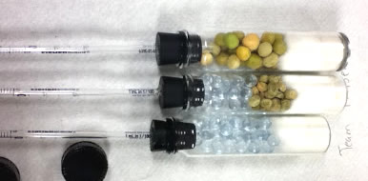

**Background**

Each individual cell is responsible for the energy exchanges necessary to sustain its ordered structure.  Cells accomplish this task by breaking down nutrient molecules to generate ATP (adenosine triphosphate), which can then be used to run cellular processes that require energy.  This process is called cellular respiration which requires nutrient molecules and oxygen.   Carbon dioxide and water are products of the series of reactions involved in cellular respiration.

equation

METHODS OF MEASURING THE RATE OF CELLULAR RESPIRATION:

There are several methods of indirectly measuring the rate of cellular respiration in organisms.  (1) One method involves monitoring changes in temperature; since the process of respiration is exergonic (produces heat).  (2) Another method is to measure either the oxygen consumption or the carbon dioxide production.  Respirometers are devices that measure these types of gas volume changes, and therefore provide information about the rate of cellular respiration.

In order to be able to use a respirometer, you will need to use the ideal gas law, which describes the relationship between temperature, pressure and volume. (PV = nrT)

During cellular respiration, two gases are changing in volume.  Oxygen gas is being consumed by the respiring cells and carbon dioxide gas is diffusing out of the cells.  The respirometer, therefore, has to be able to deal with two simultaneously changing gas volumes.  This is accomplished by introducing potassium hydroxide into the device.  KOH absorbs carbon dioxide, following this equation:

CO2 + 2KOH --> K2CO3 + H2O

Potassium carbonate (K2CO3 ) is a solid precipitate.  Any CO2 produced is immediately converted from a gas to a solid and is therefore no longer governed by gas laws.  This allows the respirometer to measure only one variable, the consumption of oxygen gas by living cells.

**Assembling the Respirometers**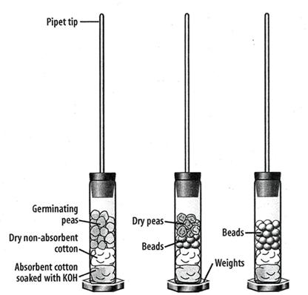

Two sets of three respirometers will be assembled during this lab exercise.  Each set will be incubated at a different temperature.  One respirometer will contain germinated seeds, one will contain a mix of non-germinating seeds and plastic beads, and a third will contain only plastic beads.

The purpose of the beads is to ensure that each respirometer is uniform in volume.  The respirometers will also contain a layer of cotton that has been saturated with KOH so that carbon dioxide will be absorbed.   The respirometers will be submerged in a pan of water; water will flow from an area of high pressure to an area of low pressure.  As oxygen is used up by the respiring seeds, the gas pressure inside the respirometer will decrease and the water will flow into the pipet down its pressure gradient.

**Lab Materials**:   50 germinating pea seeds, 50 dry seeds, 100 plastic beads, 3 respirometer vials, Weights for vials,3 stoppers, 1 ml graduated pipets, sealant (Vaseline), absorbent cotton, nonabsorbent cotton, 1 round wood stick, 3 pieces of paper towel, marking pen, water bath, ice, 100 ml graduated cylinder, thermometer, masking tape, stopwatch or clock, water. Dropper Bottle of 15% KOH

Safety – wear safety goggles.  KOH is caustic, avoid direct skin contact.

**Procedure: Day 1**

1.  Label three paper towels as follows:  1a, 2a, 3a.  These numbers will correspond to the respirometers of the same numbers. checkbox

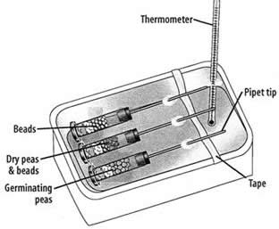2.  Fill a graduated cylinder with 20 ml of water.  Count out 25 germinating seeds and place them into the graduated cylinder.   Record the total volume of the seeds and water in the data table.  Subtract the initial 20 ml to determine the total volume of the germinating seeds.  Pour out the water from the graduated cylinder and place the 25 germinating seeds on paper towel 1a. checkbox

3.  Fill the graduated cylinder with 20ml of water.  Count out 25 dry (non-germinating) seeds and place them into the water.  Drop plastic beads into the cylinder until the final volume is the same as from step 3. 

4. Place the pea/bead mixture on paper towel 2a.  (Your goal here is to make sure each respirometer has the same volume).checkbox 

5.  Fill the graduated cylinder with 20 ml of water.  Add beads to the water until the total volume equals the final volume from steps 2 & 3.  Place the beads on paper towel 3a. checkbox

6.  Assemble the respirometers.  Begin with 3 vials, rubber stoppers and 1 ML pipets.  You will also need a sealant and a marker to label the vials 1a, 2a, 3a. checkbox

7.  Insert the **non-tapered** end of one pipet into the upper surface of one of the rubber stoppers.  It should fit tightly.  Place a layer of sealant around the junction between the pipet and the stopper so that no air can escape.  (*The pointy end of the pipet should be outside, not inside) checkbox

8.  Place a piece of absorbent cotton in the bottom of each of the weighted vials.  Push the cotton firmly into the bottom of the vial with a wooden stick or stirring rod.  Saturate the cotton in the vial with a few drops of 15% KOH, or alternatively use KOH pellets.  Use the same number of drops on each cotton ball.  *Caution, KOH is caustic.checkbox   

9.  Place a piece of nonabsorbent cotton on top of the saturated cotton in each vial.  Push the cotton to the bottom of the vial. (If using KOH pellets, only the nonabsorbent cotton is necessary to prevent peas from touching poisonous pellets.checkbox

10.  Add the peas, peas/beads, and beads to the appropriate respirometer.  Place the stoppers on each of the vials and ensure they are secured tightly.  Any leaks will cause the experiment to fail.  Set your apparatus aside for day 2. checkbox

**Day 2**

1.  Place a strip of masking tape across the narrow width of the water bath, approximately 2/3 of the way from one end (see diagram).  Place a white paper towel in the bottom of the tub so that you can more easily read pipettes. checkbox

2.  Place respirometers 1a, 2a, 3a into the room temperature water bath so that the pipets rest on the masking tape prop.  Begin time for a total of 2 minutes – this is the equilibration period, where your respirometers will become the same temperature as the water. Use a thermometer to determine the water temperature:  ____ checkbox

3. Submerge each of the tubes entirely in the water bath. Some water will enter the tip of the pipet, but the influx of water should stop fairly quickly.  If it does not stop, check the respirometer for leaks.   checkbox

4.  At this point, check to make sure you can read the pipets. The air bubble should extend from the main chamber up the tube of the pipet.  The pipet may need to be rotated so that you can see the numbers. checkbox

5.  If your respirometers float, you may need to weight them.  Some come with weights inside and some do not. You can improvise here, stainless steel dissection scissors; for instance, can serve to weight the tubes. checkbox

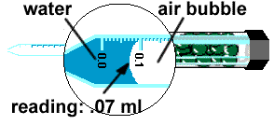6.    Record the water level in each pipet onto the data table at the Time Interval 0.  checkbox

7.  Record the position of the water in each pipet at the end of 5, 10, and 15, 20 min on Data Table 2. checkbox

8.  Remove the respirometers from the water and set aside for Day 3 checkbox

**Day 3**

*\*Alternatively, assign groups for room temperature and cold water to reduce this lab by a day.*

1.  Add ice to the water bath to lower the temperature to about 10 Celsius.    checkbox

2.  Now submerge the respirometers into the ice bath and let them sit for 2 minutes so their temperature becomes equal to the water bath temperature. checkbox

3.  Record the position of the water at 0, 5, 10, 15, 20 min. checkbox

**Extension:**   Remove your peas from the chamber and replace with a living organism. You could use a cricket or a mealworm for instance.

**DATA & ANALYSIS**

|  |  |  |  |
| --- | --- | --- | --- |
| **DATA TABLE 1: Calculation of Volume in Respirometers** | | | |
|  | Respirometer 1a (germinating seeds) | Respirometer 2a (non germinating) | Respirometer 3a (beads only) |
| Initial Volume (mL) | 20 | 20 | 20 |
| Final Volume (mL) |  |  |  |
| Volume of beads/seeds |  |  |  |

|  |  |  |  |  |  |
| --- | --- | --- | --- | --- | --- |
| **Data Table 2: Calculation of Oxygen Consumption** | | | | | |
| Respirometer 1a:  Room Temperature, Germinating Peas | | | | | |
| Time interval (min): | **0 min** | **5 min** | **10min** | **15 min** | **20 min** |
| Reading, mL |  |  |  |  |  |
| Δ  Volume, mL (reading – time 0) | N/A |  |  |  |  |
| Respirometer 2a: Room Temperature, Dry Pea Seeds | | | | | |
| Reading, mL |  |  |  |  |  |
| Δ  Volume, mL (reading – time 0) | N/A |  |  |  |  |
| Respirometer 3a:  Room Temperature, Beads Only | | | | | |
| Reading, mL |  |  |  |  |  |
| Δ  Volume, mL (reading – time 0) | N/A |  |  |  |  |
| Respirometer 1b:  10°C, Germinating Pea Seeds | | | | | |
| Time interval (min): | **0 min** | **5 min** | **10 min** | **15 min** | **20 min** |
| Reading, mL |  |  |  |  |  |
| Δ  Volume, mL (reading – time 0) |  |  |  |  |  |
| Respirometer 2b:  10°C, Dry Pea Seeds | | | | | |
| Reading, mL |  |  |  |  |  |
| Δ  Volume, mL (reading – time 0) | N/A |  |  |  |  |
| Respirometer  3b: 10°C, Beads only | | | | | |
| Reading, mL |  |  |  |  |  |
| Δ  Volume, mL (reading – time 0) | N/A |  |  |  |  |
|  | | | | | |
| **Extension:  Living Organism** | **0 min** | **5 min** | **10 min** | **15 min** | **20 min** |
| Reading, mL |  |  |  |  |  |
| Δ  Volume, mL (reading – time 0) |  |  |  |  |  |

**Graph:**  Graph a line for: Germinating Peas (room temp) | Germinating Peas (cold) | Non Germinating peas (room temp) | Non Germinating peas (cold) **Use a line of BEST FIT so that you can calculate slope**

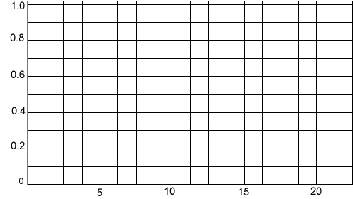

**Analysis**

1.   State a hypothesis that relates to temperature that is being tested by this lab exercise.

2.   State a hypothesis that relates to the state of seed germination that is being tested by this lab exercise.

3.  Calculate the RATE of oxygen consumption for the germinating seeds in both cold and room temperature water.  Rate can be calculated by determining the SLOPE of the line from your graph above.

4.  In this lab exercise, what is the purpose of the ….

a) Beads

b) KOH

c) Respirometer

5.  Explain why the water moved within the pipet.

6. Design another experiment to compare the respiration rates of an animal, like a worm at different temperatures (ex. At 10 ⁰C vs. 22 ⁰C). What would you predict would happen to the worm's respiration rate?

7. Compared to a worm, do you think an endothermic (warm-blooded) animal would have a higher or lower rate or respiration? Explain your prediction in terms of metabolism of the animal.

8. Imagine that you are given 25 germinating pea seeds that have been placed in boiling water for five minutes. You place these seeds in a respirometer and collect data. Predict the rate of oxygen consumption (cellular respiration) for these seeds and explain your reasons.

9. What difficulties would there be if you used a living green plant in this investigation instead of germinating seeds?

**AP BIOLOGY 2019-20 LAB ACTIVITY**

**Photosynthesis Lab**

**Floating Leaf Disk Assay**

**Introduction**

Light is a part of a continuum of radiation, or energy waves. Shorter wavelengths of energy have greater amounts of energy. For example, high-energy ultraviolet rays, with wavelengths of approximately 1 nanometer (nm) to 380 nm, can harm living tissues due to the large amount of energy they carry. Wavelengths of light within the visible part of the light spectrum power *photosynthesis*. The visible light spectrum is from about 400 to 750 nm (1 billionth of a meter). Only visible light, with its intermediate wavelengths, has enough energy to cause chemical change without destroying biological molecules. The short, high frequency waves of gamma rays (10-5 nm) have too much energy and break the hydrogen bonds found within biological molecules such as proteins and nucleic acids like DNA. The longer waves of heat, microwaves and radio waves (103 nm to 103 meters) do not possess enough energy and are absorbed by the water molecules in a plant.

When light is absorbed by leaf pigments such as *chlorophyll a or b*, electrons within each Photosystem are boosted to a higher energy level. This energy is used to produce ATP, to reduce NADP to NADPH and then used to incorporate carbon dioxide (CO2) into organic molecules in a process called *carbon fixation.* Leaf disks float, normally. When the air spaces are infiltrated with a solution the overall density of the leaf disk increases and the disk sinks. The infiltration solution includes a small amount of sodium bicarbonate (NaHCO3) thus enabling the bicarbonate ion to serve as the carbon source for photosynthesis. As photosynthesis proceeds, oxygen is released into the interior of the leaf which changes its buoyancy causing the disks to rise. Since cellular respiration is taking place at the same time within the leaf, consuming the oxygen generated by photosynthesis, the rate that the disks rise is an indirect measurement of the net rate of photosynthesis. In this lab, you will measure the net rate of photosynthesis for several plants under various lighting conditions.



**Materials:**

|  |
| --- |
| 1.               Sodium bicarbonate (Baking soda)  2.               Liquid Soap  3.               Plastic syringe (10 cc or larger)  4.               Leaf material  5.               Hole punch  6.               Plastic cups  7.               Timer  8.               Light source |

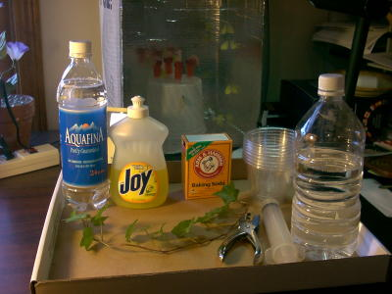

**Part A Procedure:**

1. Prepare 300 ml of bicarbonate solution for each trial.
   1. The bicarbonate serves as an alternate dissolved source of carbon dioxide for photosynthesis. Prepare a 0.2% solution. (This is not very much—it’s about 1/8 of a teaspoon of baking soda in 300 ml of water.) Too much bicarbonate will cause small bubbles (CO2) to form on the surface of the leaf which will make it difficult to sink the leaf disk.
   2. Add 1 drop of dilute liquid soap to this solution. The soap wets the hydrophobic surface of the leaf allowing the solution to be drawn into the leaf. It’s difficult to quantify this since liquid soaps vary in concentration. Avoid suds. If your solution generates suds then dilute it with more bicarbonate solution.

1. Cut 10 or more uniform leaf disks for each trial

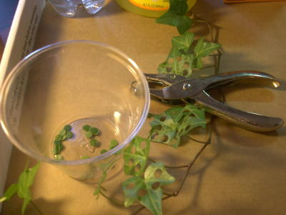

* 1. Single hole punches work well for this but stout plastic straws will work as well
  2. Choice of the leaf material is perhaps the most critical aspect of this procedure. The leaf surface should be smooth and not too thick. Avoid plants with hairy leaves. Ivy, fresh spinach, —all work well. Ivy seems to provide very consistent results. Any number of plants work.
  3. Avoid major veins.

1. Infiltrate the leaf disks with sodium bicarbonate solution.
   1. Remove the piston or plunger and place the leaf disks into the syringe barrel. Replace the plunger being careful not to crush the leaf disks. Push on the plunger until only a small volume of air and leaf disk remain in the barrel (< 10%).

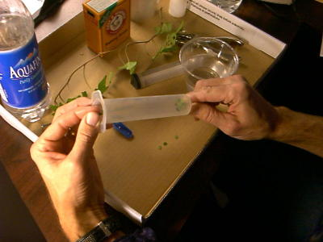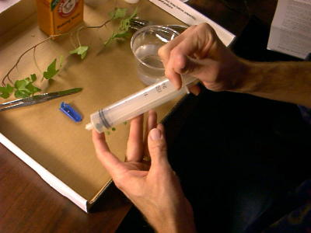

* 1. Pull a small volume of sodium bicarbonate solution into the syringe. Tap the syringe to suspend the leaf disks in the solution.

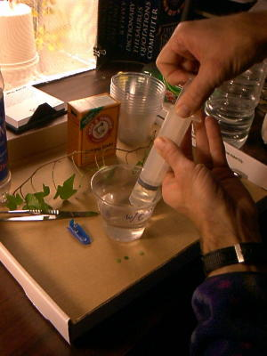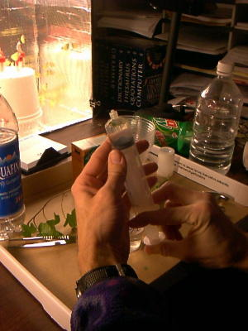

* 1. Holding a finger over the syringe-opening, draw back on the plunger to create a vacuum. Hold this vacuum for about 10 seconds. While holding the vacuum, swirl the leaf disks to suspend them in the solution. Let off the vacuum. The bicarbonate solution will infiltrate the air spaces in the leaf causing the disks to sink. You will probably have to repeat this procedure several times in order to get the disks to sink. You may have difficulty getting the disks to sink even after applying a vacuum three or four times. Generally, this is usually an indication that you need more soap in the bicarbonate solution. Some leaf surfaces are more water repellent than others are. Adding a bit more soap usually solves the problem.

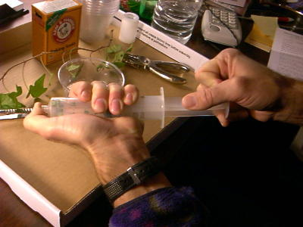

1. Pour the disks and solution into a clear plastic cup. Add bicarbonate solution to a depth of about 3 centimeters. Use the same depth for each trial. Shallower depths work just as well. Label the cup with CO2.
2. Set up a control. Infiltrate leaves with just water solution with a drop of soap---no bicarbonate. Pour the disks and solution into a clear plastic cup. Add just water solution to a depth of about 3 centimeters. Label the cup without CO2.
3. Develop a hypothesis before you begin testing.

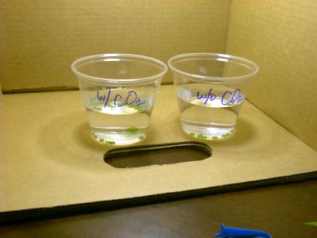

1. Place under the light source and start the timer. At the end of each minute, record the number of floating disks. Then swirl the disks to dislodge any that are stuck against the sides of the cups. Continue until all of the disks are floating.

|  |  |  |
| --- | --- | --- |
| **Time (minutes)** | **# of disks floating**  **With CO2** | **# of disks floating**  **Without CO2** |
|  |  |  |
|  |  |  |
|  |  |  |
|  |  |  |
|  |  |  |
|  |  |  |
|  |  |  |
|  |  |  |
|  |  |  |
|  |  |  |
|  |  |  |
|  |  |  |
|  |  |  |
|  |  |  |
|  |  |  |

Make a graph to analyze the data. To make comparisons between experiments, a standard point of reference is needed. Repeated testing of this procedure has shown that the point at which 50% of the

leaf disks are floating (the median or ET 50, the Estimated Time it takes 50% of the disks

to float) is a reliable and repeatable point of reference for this procedure. **Make sure to find the ET 50 of your data.**

*Sample graph to find ET 50.

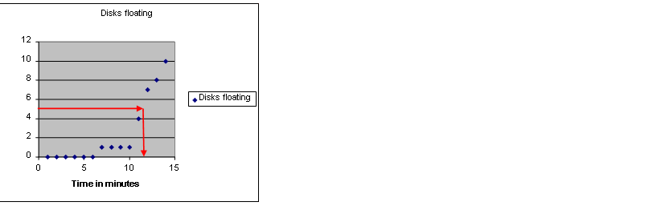

**Part B**: **Design your own experiment to test what factors affect the rate of photosynthesis**

Once you have mastered the floating disk technique, you will design an experiment

to test another variable that might affect the rate of photosynthesis. Some ideas

include the following:

* Distance of light source
* Color of light source
* Type of leaf
* Turning light off after 15 minutes
* % of bicarbonate solution

**Summary Questions:**

1) What was the function of the sodium bicarbonate in this experiment?

2) Explain the process of carbon fixation.

3) Explain the process that causes the leaf disks to rise.

4) Which trial worked the best? Explain.

5) What was the purpose of using water/soap solution for one of the trials?

6) What factors may affect photosynthesis?

**Lab Report Guidelines:**

* **Title**
* **Objective**
* **Background Information**
* **Materials**
* **Part A:**
  + **Hypothesis**
  + **Procedure**
  + **Data table**
  + **Graph with ET 50 value**
  + **Conclusion**
* **Part B:**
  + **Hypothesis**
  + **Procedure/experimental design**
  + **Data table**
  + **Graph with ET value**
  + **Conclusion**
* **Answers to summary questions**

**AP BIOLOGY 2019-20 LAB REPORT TEMPLATE**

Font Style and Size: Times New Roman, 12 Double-Spacing for the Whole Document

No Use of Bold Text Section Titles Centered and in ALL CAPS Avoid First-Person Narrative

Changes in Winogradsky column microbial diversity when limiting nutrients are introduced to environments

with varying carbon sources– a descriptive title

Your Name

April 15th, 2012 – *date of completion*

AP Biology *– Course Title*

INTRODUCTION

*This section should contain the research question(s) being addressed. Justify each question (purpose) with the objectives of the lab. Avoid being too vague by giving as much depth in your explanation as possible.*

HYPOTHESES

*Introduce both your research (alternative) hypothesis and your null hypothesis in this section. Use an ‘If, then, because’**format whenever possible. Identify the scientific reasoning behind your hypothesis. This should be a brief paragraph of explanation behind your hypothesis. Use concepts from biology to support your prediction. The null hypothesis basically states the opposite of the research hypothesis. The null can also state that there is no relationship between the tested variables. A null hypothesis is a statistical hypothesis that is tested for possible rejection under the assumption that it is true. Ex: If your research hypothesis begins as “If plants receive only green light, overall growth will be reduced, because…”, your null hypothesis could state “The color of light received by a plant will have no effect on the rate of growth.”*

EXPERIMENTAL DESIGN

VARIABLES

*Use this section to describe the independent, dependent, and controlled variables of your experiment. Remember that controlled variables are any aspect that is kept constant throughout the experiment. You should also give a detailed description of your control group and how it is used for purposes of comparison.*

MATERIALS

*Give a brief list of important materials used during the experiment. You can either literally list materials or describe them in a short paragraph. Pictures or sketches made in your lab notebook do not necessarily need to be included in this final report. If you do decide to insert a digital image, be sure it is given a proper figure title as demonstrated later in the results section.*

PROCEDURES

*Unlike in your pre-lab, this should not be a list of numbered steps. Instead, this should be a detailed recounting of the experiment that takes the reader through every step. Be sure your descriptions include how all of the above listed materials are used. This description should be easy to follow to the point of being easily reproduced by another student.*

RESULTS

*Create data tables to record your data in an organized fashion throughout the lab. This includes quantitative AND qualitative data. Qualitative data should be described in paragraph form. Avoid discussing the data here. Just state it as an observation, and save discussions for later in the conclusion section. Be sure to label units to be recorded. Data table borders should be formatted to appear similar to the example shown. Tables should be numbered (Table 1) and given a descriptive title. Note that table titles appear above the table while titles for figures appear at the bottom.*

Table 1. Column contents after eight weeks of incubation

|  |  |  |  |  |
| --- | --- | --- | --- | --- |
|  | Column 1  (no carbon added) | Column 2  (newspaper) | Column 3  (leaf litter) | Column 4  (CaCO3 - chalk) |
| Algae (*Chlorella*) | **+++** | **+** | **+** | **++** |
| Algae (*Chlamydomonas*) | **++** | **−** | **−** | **+** |
| Algae (*Euglena*) | **+** | **−** | **−** | **+** |
| Algae (diatoms) | **+** | **++** | **++** | **+** |
| Protozoa | **++** | **+** | **+** | **++** |
| *Chlorobium* | **++** | **+** | **+** | **+** |
| Ferrous sulfide or oxide | Dark sides | All sides | Dark sides | Dark sides |
| Iron oxide | Light sides | Light sides | Light sides | Light sides |

*+ through +++ indicates degree of organism observed, − indicates organisms not found*

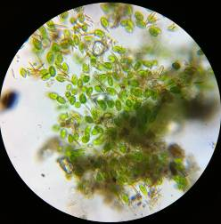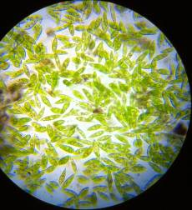

Figure 1. Dormant *Euglena* from water surface (left) and active *Euglena* from upper sediment layer (right).

Figure 2. Changes in allelic frequencies over six generations experiencing selective pressure against the homozygous recessive genotype

CONCLUSION

*Link your hypothesis, your reasoning, and this analysis together. Use your brain, your book and the internet to analyze your results. You should NOT simply say what the results are. I am looking for you to understand WHY that occurred. What are the biological explanations? Or what are the reasons for unexpected results? A continuation of your analysis should focus on how reliable/correct your data is. Identify what the expected results of the lab were and whether or not the observed results matched the expected results. Were differences due to error in method or reasoning? According to your data, do you support or reject your research hypothesis? Remember, if you reject your research hypothesis, you have most likely failed to reject your null hypothesis.*

REFERENCES

*You should always follow APA guidelines. Use websites like* [*http://www.bibme.org/*](http://www.bibme.org/) *or* [*http://citationmachine.net/*](http://citationmachine.net/) *to generate your citations in the correct formatting. List them as the sources are listed below in alphabetical order. Notice that references are not double-spaced when they exceed more than a single line. Only double space between the references.*

Adelstein, D., & Texley, J. (2006). A platform to stand on. *The Science Teacher*, *73*(7), 30-32.

Agamba, J., & Keengwe, J. (2012). Course management systems integration into course instruction .  *International Journal of Information and Communication Technology Education*, *8*(2), 72.

Brooks-Young, S. (2008). Got moodle? The free, open source program enjoys great appeal among K-12 teachers, as it allows them to get the upper hand on course management and assessment .  *T H E Journal (Technological Horizons In Education)*, *35*(4), 28.

**AP BIOLOGY 2019-20 PROJECT**

**Genetics Project - Design a Species**

<https://biologycorner.com/worksheets/genetics_project.html>

Objective: Genetics follows certain rules, as illustrated by Punnet squares, principles of dominance and recessiveness, and rules related to the location of alleles on the chromosomes. In animals, such as mouse, certain traits are expressed in predictable ways. In this project, you are going to design your own **imaginary edible species**, and create traits for the species that follow genetic rules that you have already studied.

The edible creature should have **at least 5 genetic traits** from the following list. You are free to create whatever traits you like (such as hair color, size, shape, or other features)

* 2 Single-allele traits
* 1 Codominant trait (or incomplete dominance)
* 1 Multiple allele trait
* 1 Sex linked trait

**Your final project should have the following elements:**

1. Describe, sketch, provide images each of the traits from the list, listing genotypes and phenotypes for each. *[Partial sketches are fine in this case.]*

2. Create (or sketch or provide images) two examples of your creature – one **male** and one **female**. The two examples must have different genotypes. Each sketch should have the genotype listed for all traits.

3. Pick one of your single allele traits and create a sample pedigree for your creature. The **pedigree** should include at least 4 generations.

4. Show a dihybrid cross (using your 2 single allele traits—ex: AaBb x AaBb) List the phenotypic ratios.

5. Create 5 practice problems, using any of the traits. These should be word problems. Do not just write Aa x Aa.

**DUE: November 25, 2019**

|  |  |  |  |
| --- | --- | --- | --- |
| **Genetics Project Grading Rubric** | | | |
|  | **Unsatisfactory (3 pts)** | **Satisfactory (4pts)** | **Excellent (5 pts)** |
| **Traits and pictures** | Some do not follow genetics “rules”, pictures not clear | Follows genetics rules, pictures are small or lacking in creativity or effort | Follows genetics rules, pictures are drawn large and clearly. Colored. Creative. |
| **Creature examples** | Genotype doesn’t follow phenotype, pictures not included or unclear | Genotype follows phenotype, all traits included, pictures somewhat unclear or not neat | Genotype follows phenotype, pictures drawn clearly, neatly and creatively, and colored |
| **Pedigree** | Less than 4 generations are shown, significant mistakes in genotypes | 4 generations shown, minor mistakes in genotypes | 4 generations shown, no mistakes |
| **Dihybrid Cross** | Punnett square not set up correctly, phenotypic ratios not given or incorrect | Punnett square set up correctly, minor errors in counting and ratios | Square set up correctly, phenotypic ratios given correctly |
| **Practice problems** | Less than 5 problems given, more than 1 is impossible to solve | 5 problems given, somewhat unclear or unsolvable | All 5 problems are written well and can be solved |
| **Creativity and Overall Production** | Use of ingredients lacking in imagination and somewhat appropriate for specified traits. Overall products somewhat demonstrative of genotypes.  Creatures somewhat tasty. | Use of ingredients mostly imaginative and appropriate for specified traits. Overall products mostly demonstrative of genotypes.  Creatures tasty. | Use of ingredients was ingenious as well as appropriate. Overall products clearly depict correct genotypes.  Creatures extremely tasty!! [YUM!] |
| **TOTAL** |  |  |  |