**AP BIOLOGY 2019-20 November 27, 2019**

**Today’s Agenda (Day 64)**

1. HOUSEKEEPING:

🡪

1. Homework Check:

🡪 Project Draft: List of genotypes and phenotypes

🡪 Lab Write-up:Osmosis and Diffusion

🡪 Project: Design a Species

🡪 Design a Lab: Potato Enzyme Lab

🡪 Virtual Lab: Enzyme Catalysis & Cell Respiration – notes and analysis

1. Class Activity:

🡪 **LAB:** Photosynthesis Lab – see p. 2 of document below

HOMEWORK:

* Read Unit 4 Chapters on Genetics: Chapters 15 – 16
* Complete Chapter 15 & 16 Vocabulary
* Complete Chapter 15 & 16 Notes

Chapter 15 – Chromosomal Basis of Inheritance

|  |  |  |  |  |  |
| --- | --- | --- | --- | --- | --- |
| aneuploidy | Barr body | chromosome theory of inheritance | Deletions | Down syndrome | duplications |
| genomic imprinting | Inversions | linkage map | linked genes | monosomy | nondisjunction |
| parental types | Polyploidy | recombinant types | sex-linked genes | Translocations | trisomy |

Chapter 16 – Molecular Basis of Inheritance

|  |  |  |  |  |  |
| --- | --- | --- | --- | --- | --- |
| Antiparallel | DNA ligase | DNA pol I | DNA pol III | DNA replication | double helix |
| Euchromatin | Helicase | Heterochromatin | Histone | lagging strand | leading strand |
| mismatch repair | Nucleases | Nucleosomes | nucleotide excision repair | Okazaki fragments | Phages |
| Primase | Primer | replication fork | semiconservative | Telomeres |  |

REMINDERS:

* Chapter 15 & 16 Vocabulary – December 3
* Lab Report: Potato Enzyme – December 4
* Lab Report: Photosynthesis – December 5; 11:59:59 pm
* Chapter 15 Notes – December 5
* Chapter 16 Notes – December 6
* **Chapter 15 & 16 Vocabulary Quiz 🡪 December 10**
* **TEST: Ch 15 & 16** 🡪 **December 12**

**AP BIOLOGY 2019-20 LAB ACTIVITY**

**Photosynthesis Lab**

**Floating Leaf Disk Assay**

**Introduction**

Light is a part of a continuum of radiation, or energy waves. Shorter wavelengths of energy have greater amounts of energy. For example, high-energy ultraviolet rays, with wavelengths of approximately 1 nanometer (nm) to 380 nm, can harm living tissues due to the large amount of energy they carry. Wavelengths of light within the visible part of the light spectrum power *photosynthesis*. The visible light spectrum is from about 400 to 750 nm (1 billionth of a meter). Only visible light, with its intermediate wavelengths, has enough energy to cause chemical change without destroying biological molecules. The short, high frequency waves of gamma rays (10-5 nm) have too much energy and break the hydrogen bonds found within biological molecules such as proteins and nucleic acids like DNA. The longer waves of heat, microwaves and radio waves (103 nm to 103 meters) do not possess enough energy and are absorbed by the water molecules in a plant.

When light is absorbed by leaf pigments such as *chlorophyll a or b*, electrons within each Photosystem are boosted to a higher energy level. This energy is used to produce ATP, to reduce NADP to NADPH and then used to incorporate carbon dioxide (CO2) into organic molecules in a process called *carbon fixation.* Leaf disks float, normally. When the air spaces are infiltrated with a solution the overall density of the leaf disk increases and the disk sinks. The infiltration solution includes a small amount of sodium bicarbonate (NaHCO3) thus enabling the bicarbonate ion to serve as the carbon source for photosynthesis. As photosynthesis proceeds, oxygen is released into the interior of the leaf which changes its buoyancy causing the disks to rise. Since cellular respiration is taking place at the same time within the leaf, consuming the oxygen generated by photosynthesis, the rate that the disks rise is an indirect measurement of the net rate of photosynthesis. In this lab, you will measure the net rate of photosynthesis for several plants under various lighting conditions.



**Materials:**

|  |
| --- |
| 1.               Sodium bicarbonate (Baking soda)  2.               Liquid Soap  3.               Plastic syringe (10 cc or larger)  4.               Leaf material  5.               Hole punch  6.               Plastic cups  7.               Timer  8.               Light source |

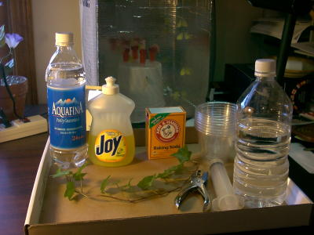

**Part A Procedure:**

1. Prepare 300 ml of bicarbonate solution for each trial.
   1. The bicarbonate serves as an alternate dissolved source of carbon dioxide for photosynthesis. Prepare a 0.2% solution. (This is not very much—it’s about 1/8 of a teaspoon of baking soda in 300 ml of water.) Too much bicarbonate will cause small bubbles (CO2) to form on the surface of the leaf which will make it difficult to sink the leaf disk.
   2. Add 1 drop of dilute liquid soap to this solution. The soap wets the hydrophobic surface of the leaf allowing the solution to be drawn into the leaf. It’s difficult to quantify this since liquid soaps vary in concentration. Avoid suds. If your solution generates suds then dilute it with more bicarbonate solution.

1. Cut 10 or more uniform leaf disks for each trial

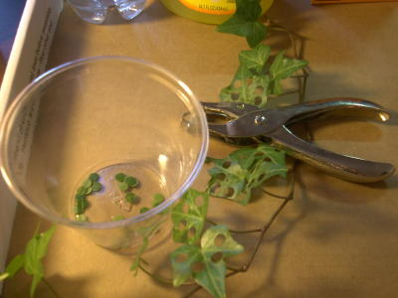

* 1. Single hole punches work well for this but stout plastic straws will work as well
  2. Choice of the leaf material is perhaps the most critical aspect of this procedure. The leaf surface should be smooth and not too thick. Avoid plants with hairy leaves. Ivy, fresh spinach, —all work well. Ivy seems to provide very consistent results. Any number of plants work.
  3. Avoid major veins.

1. Infiltrate the leaf disks with sodium bicarbonate solution.
   1. Remove the piston or plunger and place the leaf disks into the syringe barrel. Replace the plunger being careful not to crush the leaf disks. Push on the plunger until only a small volume of air and leaf disk remain in the barrel (< 10%).

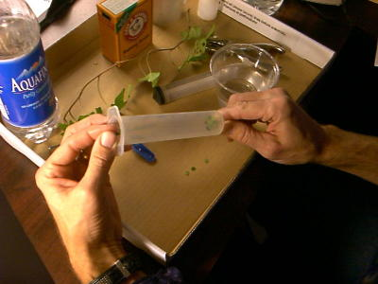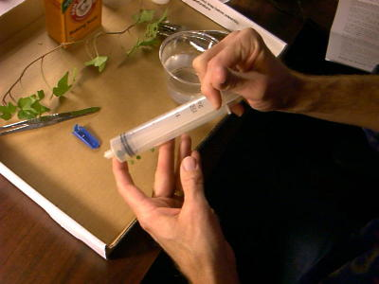

* 1. Pull a small volume of sodium bicarbonate solution into the syringe. Tap the syringe to suspend the leaf disks in the solution.

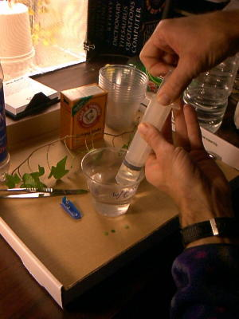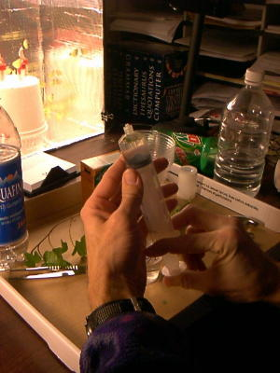

* 1. Holding a finger over the syringe-opening, draw back on the plunger to create a vacuum. Hold this vacuum for about 10 seconds. While holding the vacuum, swirl the leaf disks to suspend them in the solution. Let off the vacuum. The bicarbonate solution will infiltrate the air spaces in the leaf causing the disks to sink. You will probably have to repeat this procedure several times in order to get the disks to sink. You may have difficulty getting the disks to sink even after applying a vacuum three or four times. Generally, this is usually an indication that you need more soap in the bicarbonate solution. Some leaf surfaces are more water repellent than others are. Adding a bit more soap usually solves the problem.

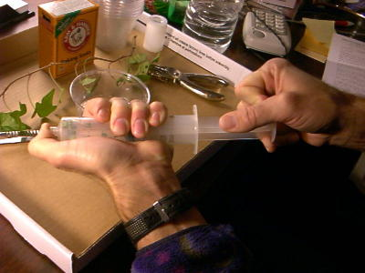

1. Pour the disks and solution into a clear plastic cup. Add bicarbonate solution to a depth of about 3 centimeters. Use the same depth for each trial. Shallower depths work just as well. Label the cup with CO2.
2. Set up a control. Infiltrate leaves with just water solution with a drop of soap---no bicarbonate. Pour the disks and solution into a clear plastic cup. Add just water solution to a depth of about 3 centimeters. Label the cup without CO2.
3. Develop a hypothesis before you begin testing.

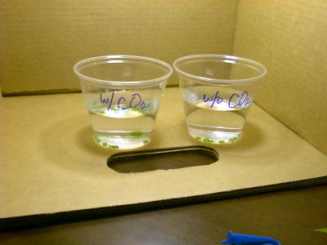

1. Place under the light source and start the timer. At the end of each minute, record the number of floating disks. Then swirl the disks to dislodge any that are stuck against the sides of the cups. Continue until all of the disks are floating.

|  |  |  |
| --- | --- | --- |
| **Time (minutes)** | **# of disks floating**  **With CO2** | **# of disks floating**  **Without CO2** |
|  |  |  |
|  |  |  |
|  |  |  |
|  |  |  |
|  |  |  |
|  |  |  |
|  |  |  |
|  |  |  |
|  |  |  |
|  |  |  |
|  |  |  |
|  |  |  |
|  |  |  |
|  |  |  |
|  |  |  |

Make a graph to analyze the data. To make comparisons between experiments, a standard point of reference is needed. Repeated testing of this procedure has shown that the point at which 50% of the

leaf disks are floating (the median or ET 50, the Estimated Time it takes 50% of the disks

to float) is a reliable and repeatable point of reference for this procedure. **Make sure to find the ET 50 of your data.**

*Sample graph to find ET 50.

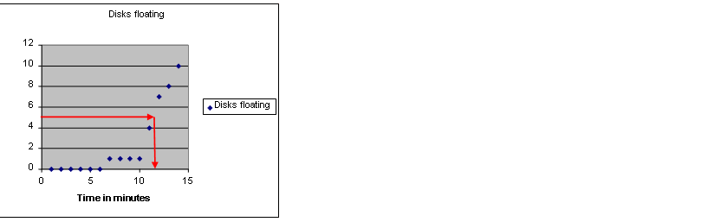

**Part B**: **Design your own experiment to test what factors affect the rate of photosynthesis**

Once you have mastered the floating disk technique, you will design an experiment

to test another variable that might affect the rate of photosynthesis. Some ideas

include the following:

* Distance of light source
* Color of light source
* Type of leaf
* Turning light off after 15 minutes
* % of bicarbonate solution

**Summary Questions:**

1) What was the function of the sodium bicarbonate in this experiment?

2) Explain the process of carbon fixation.

3) Explain the process that causes the leaf disks to rise.

4) Which trial worked the best? Explain.

5) What was the purpose of using water/soap solution for one of the trials?

6) What factors may affect photosynthesis?

**Lab Report Guidelines:**

* **Title**
* **Objective**
* **Background Information**
* **Materials**
* **Part A:**
  + **Hypothesis**
  + **Procedure**
  + **Data table**
  + **Graph with ET 50 value**
  + **Conclusion**
* **Part B:**
  + **Hypothesis**
  + **Procedure/experimental design**
  + **Data table**
  + **Graph with ET value**
  + **Conclusion**
* **Answers to summary questions**

**AP BIOLOGY 2019-20 LAB ACTIVITY**

Potato Enzyme Lab

INTRODUCTION

An enzyme is a protein that speeds up or slows down a specific chemical reaction in an organism. A good rule of thumb is to remember that enzyme names end in “-ase”. This will help in identifying enzymes in further readings. Generally, enzymes are catalysts.

Hydrogen peroxide is a toxic chemical that is produced in many organisms during metabolism. Organisms must get rid of this toxin to survive. One reaction turns the hydrogen peroxide into water and oxygen. The enzyme that helps with this reaction is called catalase. This is found in both plants and animals. In this lab we will use potatoes as our catalase source. The reaction equation is:

Catalase   
2H2O2 🡪 2H2O + O2

PURPOSE

1. Observe the breakdown of hydrogen peroxide toxin by potato’s enzyme catalase.
2. Determine factors that influence how quickly the reaction takes place.
3. Determine factors that influence how well enzymes function.
4. Use graphic analysis (graphing) to analyze our results.

PRELAB QUESTIONS

1. What test tube is the control group? Why?
2. Formulate a hypothesis.

Materials:

4 test tubes  
test tube rack  
graduated cylinder  
hydrogen peroxide  
potato (ground, diced, diced and cooked)  
timer

PROCEDURE

1. Mark test tubes 1-4.
2. Fill each test tube with 5mL hydrogen peroxide.
3. Make initial observations of test tube one.
4. Obtain about 1g ground potato and add it to test tube 2.
5. Time how long it takes for the reaction to take place. You’ll know the reaction is taking place because bubbles are made.
6. Obtain about 1g of diced potato. Record the exact mass and add it to test tube 3.
7. Time how long it takes for the reaction to take place. You’ll know the reaction is taking place because bubbles are made.
8. Obtain about 1g of cooked potato. Record the exact mass and add it to test tube 4.
9. Time how long it takes for the reaction to take place. You’ll know the reaction is taking place because bubbles are made.

DATA AND OBSERVATIONS

|  |  |  |
| --- | --- | --- |
| Test tube | Observations | Time for reaction (s) |
| 1.  Nothing |  |  |
| 2.  Ground Potato |  |  |
| 3.  Diced Potato |  |  |
| 4.  Cooked Potato |  |  |

DATA ANALYSIS

1. Calculate a rate of reaction per gram of potato for each trial. Rate = time/grams
2. Graph the data. Include a title, labels, units, and a key.

Type of graph: bar/column graph

Analysis Questions

1. What did the catalase do? How do you know?
2. What did grinding the potato up do to the rate? Why did this change the rate?
3. What did cooking the potato do to the rate? What conclusion can you draw about that result?

**AP BIOLOGY 2019-20 LAB REPORT TEMPLATE**

Font Style and Size: Times New Roman, 12 Double-Spacing for the Whole Document

No Use of Bold Text Section Titles Centered and in ALL CAPS Avoid First-Person Narrative

Changes in Winogradsky column microbial diversity when limiting nutrients are introduced to environments

with varying carbon sources– a descriptive title

Your Name

April 15th, 2012 – *date of completion*

AP Biology *– Course Title*

INTRODUCTION

*This section should contain the research question(s) being addressed. Justify each question (purpose) with the objectives of the lab. Avoid being too vague by giving as much depth in your explanation as possible.*

HYPOTHESES

*Introduce both your research (alternative) hypothesis and your null hypothesis in this section. Use an ‘If, then, because’**format whenever possible. Identify the scientific reasoning behind your hypothesis. This should be a brief paragraph of explanation behind your hypothesis. Use concepts from biology to support your prediction. The null hypothesis basically states the opposite of the research hypothesis. The null can also state that there is no relationship between the tested variables. A null hypothesis is a statistical hypothesis that is tested for possible rejection under the assumption that it is true. Ex: If your research hypothesis begins as “If plants receive only green light, overall growth will be reduced, because…”, your null hypothesis could state “The color of light received by a plant will have no effect on the rate of growth.”*

EXPERIMENTAL DESIGN

VARIABLES

*Use this section to describe the independent, dependent, and controlled variables of your experiment. Remember that controlled variables are any aspect that is kept constant throughout the experiment. You should also give a detailed description of your control group and how it is used for purposes of comparison.*

MATERIALS

*Give a brief list of important materials used during the experiment. You can either literally list materials or describe them in a short paragraph. Pictures or sketches made in your lab notebook do not necessarily need to be included in this final report. If you do decide to insert a digital image, be sure it is given a proper figure title as demonstrated later in the results section.*

PROCEDURES

*Unlike in your pre-lab, this should not be a list of numbered steps. Instead, this should be a detailed recounting of the experiment that takes the reader through every step. Be sure your descriptions include how all of the above listed materials are used. This description should be easy to follow to the point of being easily reproduced by another student.*

RESULTS

*Create data tables to record your data in an organized fashion throughout the lab. This includes quantitative AND qualitative data. Qualitative data should be described in paragraph form. Avoid discussing the data here. Just state it as an observation, and save discussions for later in the conclusion section. Be sure to label units to be recorded. Data table borders should be formatted to appear similar to the example shown. Tables should be numbered (Table 1) and given a descriptive title. Note that table titles appear above the table while titles for figures appear at the bottom.*

Table 1. Column contents after eight weeks of incubation

|  |  |  |  |  |
| --- | --- | --- | --- | --- |
|  | Column 1  (no carbon added) | Column 2  (newspaper) | Column 3  (leaf litter) | Column 4  (CaCO3 - chalk) |
| Algae (*Chlorella*) | **+++** | **+** | **+** | **++** |
| Algae (*Chlamydomonas*) | **++** | **−** | **−** | **+** |
| Algae (*Euglena*) | **+** | **−** | **−** | **+** |
| Algae (diatoms) | **+** | **++** | **++** | **+** |
| Protozoa | **++** | **+** | **+** | **++** |
| *Chlorobium* | **++** | **+** | **+** | **+** |
| Ferrous sulfide or oxide | Dark sides | All sides | Dark sides | Dark sides |
| Iron oxide | Light sides | Light sides | Light sides | Light sides |

*+ through +++ indicates degree of organism observed, − indicates organisms not found*

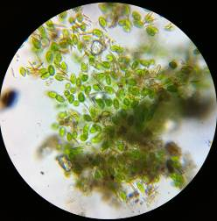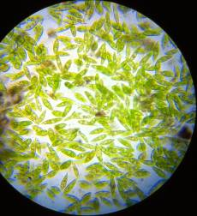

Figure 1. Dormant *Euglena* from water surface (left) and active *Euglena* from upper sediment layer (right).

Figure 2. Changes in allelic frequencies over six generations experiencing selective pressure against the homozygous recessive genotype

CONCLUSION

*Link your hypothesis, your reasoning, and this analysis together. Use your brain, your book and the internet to analyze your results. You should NOT simply say what the results are. I am looking for you to understand WHY that occurred. What are the biological explanations? Or what are the reasons for unexpected results? A continuation of your analysis should focus on how reliable/correct your data is. Identify what the expected results of the lab were and whether or not the observed results matched the expected results. Were differences due to error in method or reasoning? According to your data, do you support or reject your research hypothesis? Remember, if you reject your research hypothesis, you have most likely failed to reject your null hypothesis.*

REFERENCES

*You should always follow APA guidelines. Use websites like* [*http://www.bibme.org/*](http://www.bibme.org/) *or* [*http://citationmachine.net/*](http://citationmachine.net/) *to generate your citations in the correct formatting. List them as the sources are listed below in alphabetical order. Notice that references are not double-spaced when they exceed more than a single line. Only double space between the references.*

Adelstein, D., & Texley, J. (2006). A platform to stand on. *The Science Teacher*, *73*(7), 30-32.

Agamba, J., & Keengwe, J. (2012). Course management systems integration into course instruction .  *International Journal of Information and Communication Technology Education*, *8*(2), 72.

Brooks-Young, S. (2008). Got moodle? The free, open source program enjoys great appeal among K-12 teachers, as it allows them to get the upper hand on course management and assessment .  *T H E Journal (Technological Horizons In Education)*, *35*(4), 28.

**AP BIOLOGY 2019-20 PROJECT**

**Genetics Project - Design a Species**

<https://biologycorner.com/worksheets/genetics_project.html>

Objective: Genetics follows certain rules, as illustrated by Punnet squares, principles of dominance and recessiveness, and rules related to the location of alleles on the chromosomes. In animals, such as mouse, certain traits are expressed in predictable ways. In this project, you are going to design your own **imaginary edible species**, and create traits for the species that follow genetic rules that you have already studied.

The edible creature should have **at least 5 genetic traits** from the following list. You are free to create whatever traits you like (such as hair color, size, shape, or other features)

* 2 Single-allele traits
* 1 Codominant trait (or incomplete dominance)
* 1 Multiple allele trait
* 1 Sex linked trait

**Your final project should have the following elements:**

1. Describe, sketch, provide images each of the traits from the list, listing genotypes and phenotypes for each. *[Partial sketches are fine in this case.]*

2. Create (or sketch or provide images) two examples of your creature – one **male** and one **female**. The two examples must have different genotypes. Each sketch should have the genotype listed for all traits.

3. Pick one of your single allele traits and create a sample pedigree for your creature. The **pedigree** should include at least 4 generations.

4. Show a dihybrid cross (using your 2 single allele traits—ex: AaBb x AaBb) List the phenotypic ratios.

5. Create 5 practice problems, using any of the traits. These should be word problems. Do not just write Aa x Aa.

**DUE: November 25, 2019**

|  |  |  |  |
| --- | --- | --- | --- |
| **Genetics Project Grading Rubric** | | | |
|  | **Unsatisfactory (3 pts)** | **Satisfactory (4pts)** | **Excellent (5 pts)** |
| **Traits and pictures** | Some do not follow genetics “rules”, pictures not clear | Follows genetics rules, pictures are small or lacking in creativity or effort | Follows genetics rules, pictures are drawn large and clearly. Colored. Creative. |
| **Creature examples** | Genotype doesn’t follow phenotype, pictures not included or unclear | Genotype follows phenotype, all traits included, pictures somewhat unclear or not neat | Genotype follows phenotype, pictures drawn clearly, neatly and creatively, and colored |
| **Pedigree** | Less than 4 generations are shown, significant mistakes in genotypes | 4 generations shown, minor mistakes in genotypes | 4 generations shown, no mistakes |
| **Dihybrid Cross** | Punnett square not set up correctly, phenotypic ratios not given or incorrect | Punnett square set up correctly, minor errors in counting and ratios | Square set up correctly, phenotypic ratios given correctly |
| **Practice problems** | Less than 5 problems given, more than 1 is impossible to solve | 5 problems given, somewhat unclear or unsolvable | All 5 problems are written well and can be solved |
| **Creativity and Overall Production** | Use of ingredients lacking in imagination and somewhat appropriate for specified traits. Overall products somewhat demonstrative of genotypes.  Creatures somewhat tasty. | Use of ingredients mostly imaginative and appropriate for specified traits. Overall products mostly demonstrative of genotypes.  Creatures tasty. | Use of ingredients was ingenious as well as appropriate. Overall products clearly depict correct genotypes.  Creatures extremely tasty!! [YUM!] |
| **TOTAL** |  |  |  |