AP BIOLOGY 2019-20 November 22, 2019

Today’s Agenda (Day 61)
- Homework Check:
Virtual Lab: Diffusion & Osmosis – Notes and Exercises
Project Draft: List of genotypes and phenotypes

- Class Activity:
QUIZ: Genetic Crosses
Lab: Diffusion & Osmosis – [Day 2] – Record Observations

HOMEWORK:
- Read Unit 4 Chapters on Genetics: Chapters 15 – 16
- Complete Chapter 15 & 16 Vocabulary
- Complete Chapter 15 & 16 Notes
- Complete Lab Write-Up: Diffusion and Osmosis see template in document below
- Complete Project: Design a Species

Chapter 15 – Chromosomal Basis of Inheritance
aneuploidy | Barr body | chromosome theory of inheritance | Deletions | Down syndrome | duplications
genomic imprinting | Inversions | linkage map | linked genes | monosomy | nondisjunction
parental types | Polyploidy | recombinant types | sex-linked genes | Translocations | trisomy

Chapter 16 – Molecular Basis of Inheritance
Antiparallel | DNA ligase | DNA pol I | DNA pol III | DNA replication | double helix
Euchromatin | Helicase | Heterochromatin | Histone | lagging strand | leading strand
mismatch repair | Nucleases | Nucleosomes | nucleotide excision repair | Okazaki fragments | Phages
Primase | Primer | replication fork | semiconservative | Telomeres

REMINDERS:
- Project Draft: Listing of genotypes and phenotypes for P and F1 – November 22
- Project: Design a Species – November 26
- Lab Write-up: Osmosis and Diffusion – November - 25
- Chapter 15 & 16 Vocabulary – December 3
- Chapter 15 Notes – December 5
- Chapter 16 Notes – December 6
- Chapter 15 & 16 Vocabulary Quiz December 10
- TEST: Ch 15 & 16 December 12

AP BIOLOGY 2019-20 LAB ACTIVITY

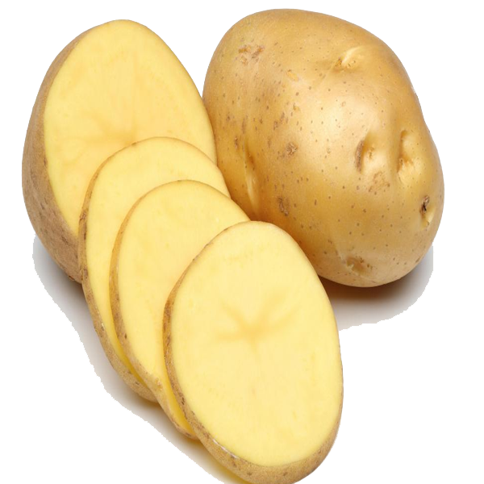
Investigation: The Effect of Salt on a Potato

What do you think will happen if you soak a potato in salt water overnight?

Pre Lab Discussion:

- Consider what you know about osmosis and transport across the membrane and ​PREDICT​ what will happen to potato slices soaked in salt water. Describe your predictions below.

- If you are going to place potato slices in ​salt water​, what do you need to set up as your ​CONTROL​?

3. Formulate your hypothesis for each of the variables. What do you think will happen to the mass of each potato sample when place in Variables 1, 2 and 3?

Procedure and Data Collection:
  - Use a scale to weigh your potato slices in grams. {Use a paper towel to soak up excess water.}

Mass of Potato Slice 1 _____ Mass of Potato Slice 2 _____ Mass of Potato Slice 3 _____

Mass of Potato Cubes 1 _____ Mass of Potato Cubes 2 _____ Mass of Potato Cubes 3 _____

  - Place potato slice 1 in a [cup] of ​salt water​, place potato slice 2 in a [cup] of ​distilled water​, place potato slice 3 in a [cup] of sugar water/colored water

  - Use a sharpie to label the cups as SALT or DI water or SUGAR/COLOR and write your initials. ​Let sit overnight.

  - Weigh each of the slices the next day.

Mass of Potato Slice 1 _____ Mass of Potato Slice 2 _____ Mass of Potato Slice 3 _____
Mass of Potato Cubes 1 _____ Mass of Potato Cubes 2 _____ Mass of Potato Cubes 3 _____

Analysis & Summary

​4. Describe what happened​ to the mass of each slice (did it go up, down, or stay the same. Present quantifiable data in a table format. Write in complete sentences to describe qualitative observations.
5. Refer to your notes or your understanding about osmosis. ​Explain WHY​ you got these results.
Write in complete and thoughtful sentences, using the following concepts in your explanation: ​osmosis​, ​cells, ​ solutes, solvent, ​solution, water potential

6. Summarize your findings. Discuss the implications in biological systems.

AP BIOLOGY 2019-20 LAB REPORT TEMPLATE

Font Style and Size: Times New Roman, 12 Double-Spacing for the Whole Document
No Use of Bold Text Section Titles Centered and in ALL CAPS Avoid First-Person Narrative

Changes in Winogradsky column microbial diversity when limiting nutrients are introduced to environments
with varying carbon sources – a descriptive title
Your Name
April 15th, 2012 – date of completion
AP Biology – Course Title
INTRODUCTION
This section should contain the research question(s) being addressed. Justify each question (purpose) with the objectives of the lab. Avoid being too vague by giving as much depth in your explanation as possible.
HYPOTHESES
Introduce both your research (alternative) hypothesis and your null hypothesis in this section. Use an ‘If, then, because’ format whenever possible. Identify the scientific reasoning behind your hypothesis. This should be a brief paragraph of explanation behind your hypothesis. Use concepts from biology to support your prediction. The null hypothesis basically states the opposite of the research hypothesis. The null can also state that there is no relationship between the tested variables. A null hypothesis is a statistical hypothesis that is tested for possible rejection under the assumption that it is true. Ex: If your research hypothesis begins as “If plants receive only green light, overall growth will be reduced, because…”, your null hypothesis could state “The color of light received by a plant will have no effect on the rate of growth.”

EXPERIMENTAL DESIGN
VARIABLES
Use this section to describe the independent, dependent, and controlled variables of your experiment. Remember that controlled variables are any aspect that is kept constant throughout the experiment. You should also give a detailed description of your control group and how it is used for purposes of comparison.
MATERIALS
Give a brief list of important materials used during the experiment. You can either literally list materials or describe them in a short paragraph. Pictures or sketches made in your lab notebook do not necessarily need to be included in this final report. If you do decide to insert a digital image, be sure it is given a proper figure title as demonstrated later in the results section.
PROCEDURES
Unlike in your pre-lab, this should not be a list of numbered steps. Instead, this should be a detailed recounting of the experiment that takes the reader through every step. Be sure your descriptions include how all of the above listed materials are used. This description should be easy to follow to the point of being easily reproduced by another student.
RESULTS
Create data tables to record your data in an organized fashion throughout the lab. This includes quantitative AND qualitative data. Qualitative data should be described in paragraph form. Avoid discussing the data here. Just state it as an observation, and save discussions for later in the conclusion section. Be sure to label units to be recorded. Data table borders should be formatted to appear similar to the example shown. Tables should be numbered (Table 1) and given a descriptive title. Note that table titles appear above the table while titles for figures appear at the bottom.

Table 1. Column contents after eight weeks of incubation
 | Column 1  (no carbon added) | Column 2  (newspaper) | Column 3  (leaf litter) | Column 4  (CaCO₃ - chalk)
Algae (Chlorella) | +++ | + | + | ++
Algae (Chlamydomonas) | ++ | − | − | +
Algae (Euglena) | + | − | − | +
Algae (diatoms) | + | ++ | ++ | +
Protozoa | ++ | + | + | ++
Chlorobium | ++ | + | + | +
Ferrous sulfide or oxide | Dark sides | All sides | Dark sides | Dark sides
Iron oxide | Light sides | Light sides | Light sides | Light sides
+ through +++ indicates degree of organism observed, − indicates organisms not found

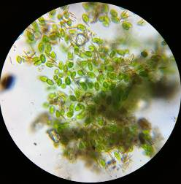
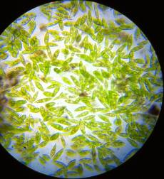

Figure 1. Dormant Euglena from water surface (left) and active Euglena from upper sediment layer (right).

Figure 2. Changes in allelic frequencies over six generations experiencing selective pressure against the homozygous recessive genotype

CONCLUSION
Link your hypothesis, your reasoning, and this analysis together. Use your brain, your book and the internet to analyze your results. You should NOT simply say what the results are. I am looking for you to understand WHY that occurred. What are the biological explanations? Or what are the reasons for unexpected results? A continuation of your analysis should focus on how reliable/correct your data is. Identify what the expected results of the lab were and whether or not the observed results matched the expected results. Were differences due to error in method or reasoning? According to your data, do you support or reject your research hypothesis? Remember, if you reject your research hypothesis, you have most likely failed to reject your null hypothesis.
REFERENCES
You should always follow APA guidelines. Use websites like http://www.bibme.org/ or http://citationmachine.net/ to generate your citations in the correct formatting. List them as the sources are listed below in alphabetical order. Notice that references are not double-spaced when they exceed more than a single line. Only double space between the references.

Adelstein, D., & Texley, J. (2006). A platform to stand on. The Science Teacher, 73(7), 30-32.

Agamba, J., & Keengwe, J. (2012). Course management systems integration into course instruction . International Journal of Information and Communication Technology Education, 8(2), 72.

Brooks-Young, S. (2008). Got moodle? The free, open source program enjoys great appeal among K-12 teachers, as it allows them to get the upper hand on course management and assessment . T H E Journal (Technological Horizons In Education), 35(4), 28.

AP BIOLOGY 2019-20 PROJECT

Genetics Project - Design a Species
https://biologycorner.com/worksheets/genetics_project.html
Objective: Genetics follows certain rules, as illustrated by Punnet squares, principles of dominance and recessiveness, and rules related to the location of alleles on the chromosomes. In animals, such as mouse, certain traits are expressed in predictable ways. In this project, you are going to design your own imaginary edible species, and create traits for the species that follow genetic rules that you have already studied.
The edible creature should have at least 5 genetic traits from the following list. You are free to create whatever traits you like (such as hair color, size, shape, or other features)
- 2 Single-allele traits
- 1 Codominant trait (or incomplete dominance)
- 1 Multiple allele trait
- 1 Sex linked trait

Your final project should have the following elements:
1. Describe, sketch, provide images each of the traits from the list, listing genotypes and phenotypes for each. [Partial sketches are fine in this case.]
2. Create (or sketch or provide images) two examples of your creature – one male and one female. The two examples must have different genotypes. Each sketch should have the genotype listed for all traits.
3. Pick one of your single allele traits and create a sample pedigree for your creature. The pedigree should include at least 4 generations.
4. Show a dihybrid cross (using your 2 single allele traits—ex: AaBb x AaBb) List the phenotypic ratios.
5. Create 5 practice problems, using any of the traits. These should be word problems. Do not just write Aa x Aa.
DUE: November 25, 2019
Genetics Project Grading Rubric
 | Unsatisfactory (3 pts) | Satisfactory (4pts) | Excellent (5 pts)
Traits and pictures | Some do not follow genetics “rules”, pictures not clear | Follows genetics rules, pictures are small or lacking in creativity or effort | Follows genetics rules, pictures are drawn large and clearly. Colored. Creative.
Creature examples | Genotype doesn’t follow phenotype, pictures not included or unclear | Genotype follows phenotype, all traits included, pictures somewhat unclear or not neat | Genotype follows phenotype, pictures drawn clearly, neatly and creatively, and colored
Pedigree | Less than 4 generations are shown, significant mistakes in genotypes | 4 generations shown, minor mistakes in genotypes | 4 generations shown, no mistakes
Dihybrid Cross | Punnett square not set up correctly, phenotypic ratios not given or incorrect | Punnett square set up correctly, minor errors in counting and ratios | Square set up correctly, phenotypic ratios given correctly
Practice problems | Less than 5 problems given, more than 1 is impossible to solve | 5 problems given, somewhat unclear or unsolvable | All 5 problems are written well and can be solved
Creativity and Overall Production | Use of ingredients lacking in imagination and somewhat appropriate for specified traits. Overall products somewhat demonstrative of genotypes.  Creatures somewhat tasty. | Use of ingredients mostly imaginative and appropriate for specified traits. Overall products mostly demonstrative of genotypes.  Creatures tasty. | Use of ingredients was ingenious as well as appropriate. Overall products clearly depict correct genotypes.  Creatures extremely tasty!! [YUM!]
TOTAL

